**Machine learning in Agriculture**

**Introduction**

Recently we have observed the emerging concept of smart farming that makes agriculture more efficient and effective with the help of high-precision algorithms. The mechanism that drives it is Machine Learning — the scientific field that gives machines the ability to learn without being strictly programmed. It has emerged together with big data technologies and high-performance computing to create new opportunities to unravel, quantify, and understand data intensive processes in agricultural operational environments.

Machine learning is everywhere throughout the whole growing and harvesting cycle. It begins with a seed being planted in the soil — from the soil preparation, seeds breeding and water feed measurement — and it ends when neural networks pick up the harvest determining the ripeness with the help of computer vision.



**Content**

AI applications in agriculture have developed applications and tools which aids in inaccurate and controlled farming by providing proper guidance to farmers about water management, crop rotation, timely harvesting, type of crop to be grown, optimum planting, pest attacks, nutrition management.

While using the machine learning algorithms in connection with images captured by satellites and drones, AI-enabled technologies predict weather conditions, analyse crop sustainability and evaluate farms for the presence of diseases or pests and poor plant nutrition on farms with data like temperature, precipitation, wind speed, and solar radiation.

Artificial Intelligence in agriculture is not only helping farmers to automate their farming but also shifts to precise cultivation for higher crop yield and better quality while using fewer resources.

**Problem definition:**

Agriculture plays a very pivotal role in the global economy of the country. Due to the increase in population, there is constant pressure on the agricultural system to improve the productivity of the crops and to grow more crops.

Hence machine learning in agriculture is used to improve the productivity and quality of the crops in the agriculture sector.

The aim is to determine the outcome of the harvest season, i.e. whether the crop would be healthy (alive), damaged by pesticides or damaged by other reasons.

**Dataset:**

**Training set**

<https://github.com/dsrscientist/Data-Science-ML-Capstone-Projects/blob/master/train_agriculture.xlsx>

**Testing set**

<https://github.com/dsrscientist/Data-Science-ML-Capstone-Projects/blob/master/test_agriculture.xlsx>

As the training and test datasets are available separately we will deal with them one by one. We shall first train and test the train_dataset , build the model and then use the saved model to make predictions for test dataset

In order to make the article intuitive, we will learn all the concepts while simultaneously working on the dataset–

In this article we will be dealing with the entire lifecycle of Data science.

Science is a very crucial and important part of our lives nowadays, through which we can solve any difficulties in our lives. However, we only know little about how science has to go through many problems of its own. In order to apply this science and overcome the problem, data is required.

This term **‘Data Science’** was discovered in the 90’s. Moreover, to achieve this, a systematic flow with a general structure needs to take place which is known as ‘Data Science project life cycle’.

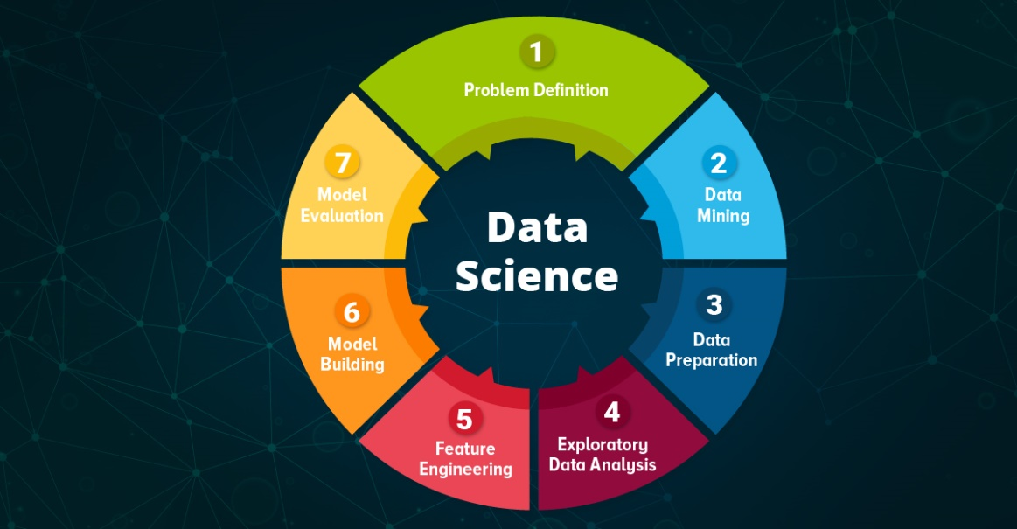

The entire process of how a complete life cycle of data science project takes place includes several successful steps such as data preparation, cleaning, model evaluation, modelling, etc. These steps rely on numerous data science tools and data scientist skills.

The steps mentioned above are the complete life cycle of a data science project. It is an iterative process which needs many repetitions until perfection is achieved. Every step is important in order to have a proper and accurate outcome of a data science project.

We will be going through every phase of this lifecycle and have a thorough look into it

To begin with let us first understand the data:

**Data Description:**

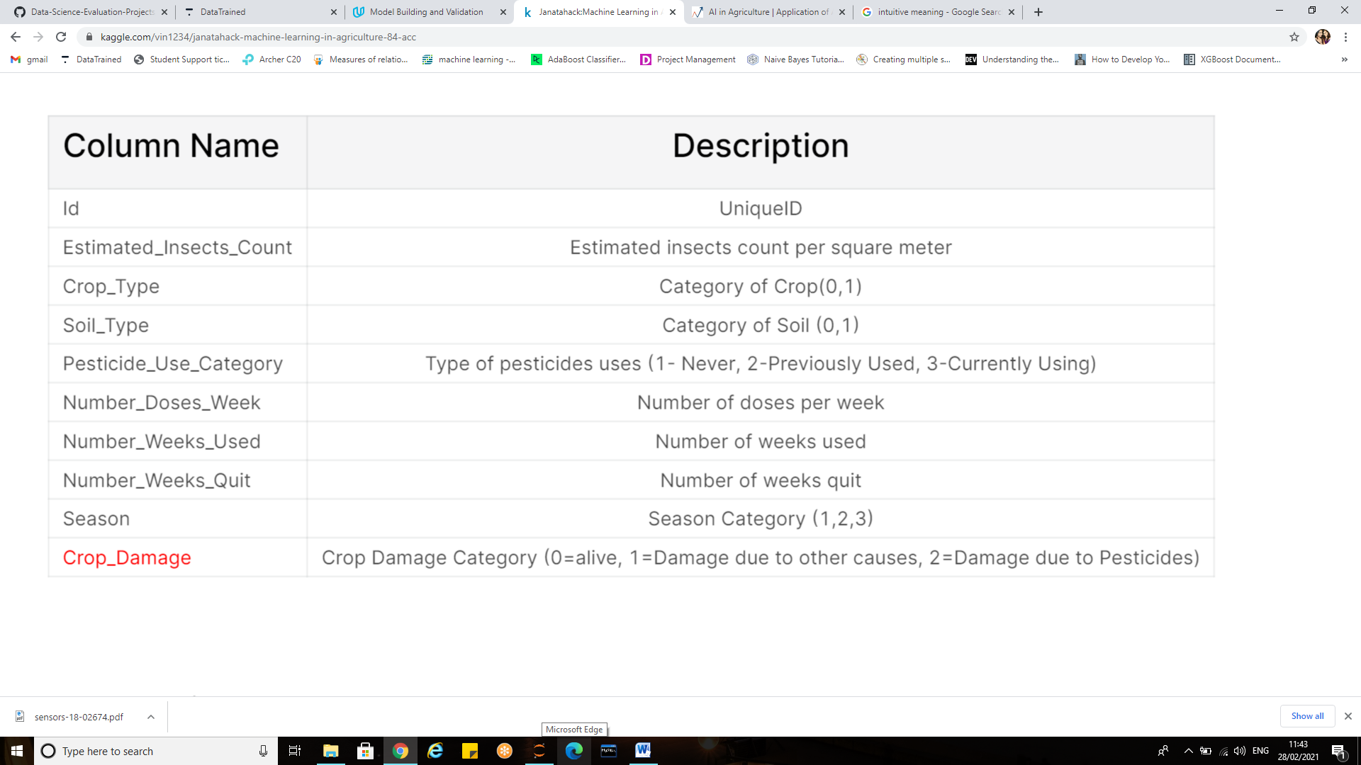

**Exploratory Data Analysis:**

*Exploration, is the key, with exploration will come failure and these failures will guide our next step and persistence are the elements of innovation*



Why analyse data?

Very often it is not the drawing that is the most difficult, but rather what to draw on a blank white piece of paper that stumps people.

Similarly for data science, one may wonder how to get started after receiving the dataset. This is where Exploratory data analysis (EDA) comes to the rescue.

Data in itself is merely facts and figures so it is a good practice to understand the data first and try to gather as many insights from it.

EDA is all about making sense of data in hand, before getting them dirty with it. It involves organizing, interpreting, structuring and presenting the data into useful information that provides context for the data.

Data Analysis helps to:

* Explore the meaning behind numbers and figures
* Analyse the cause of certain events based on data findings
* Present technical insights.
* Study the hidden and underlying trends in data

Python is a great language for doing data analysis, primarily because of the fantastic ecosystem of data-centric Python packages. Pandas are one of those packages and makes importing and analysing data much easier.

To start with let us import all necessary libraries and packages.

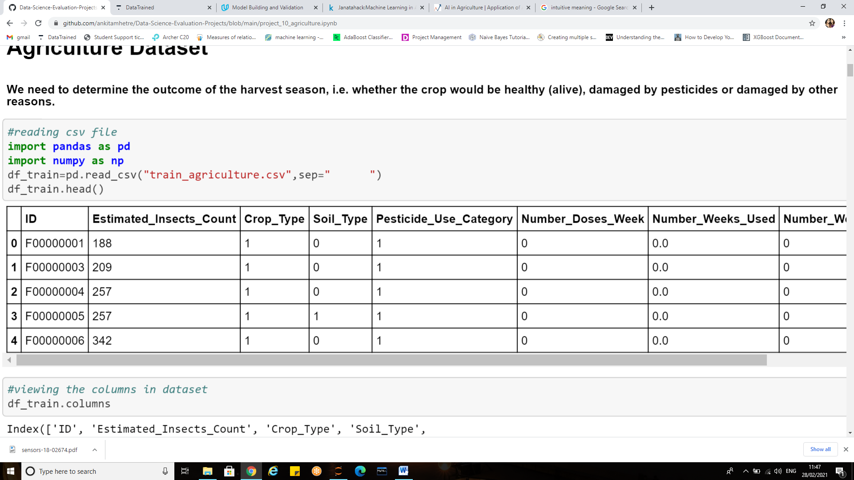

The dataset is present as a csv (comma separated value)file and is loaded using pd.read_csv function.

df_train.head ():This function returns the first n rows for the object based on position. It is useful for quickly testing if your object has the right type of data in it.

Similarly “.tail()” returns last five observations of the data set.

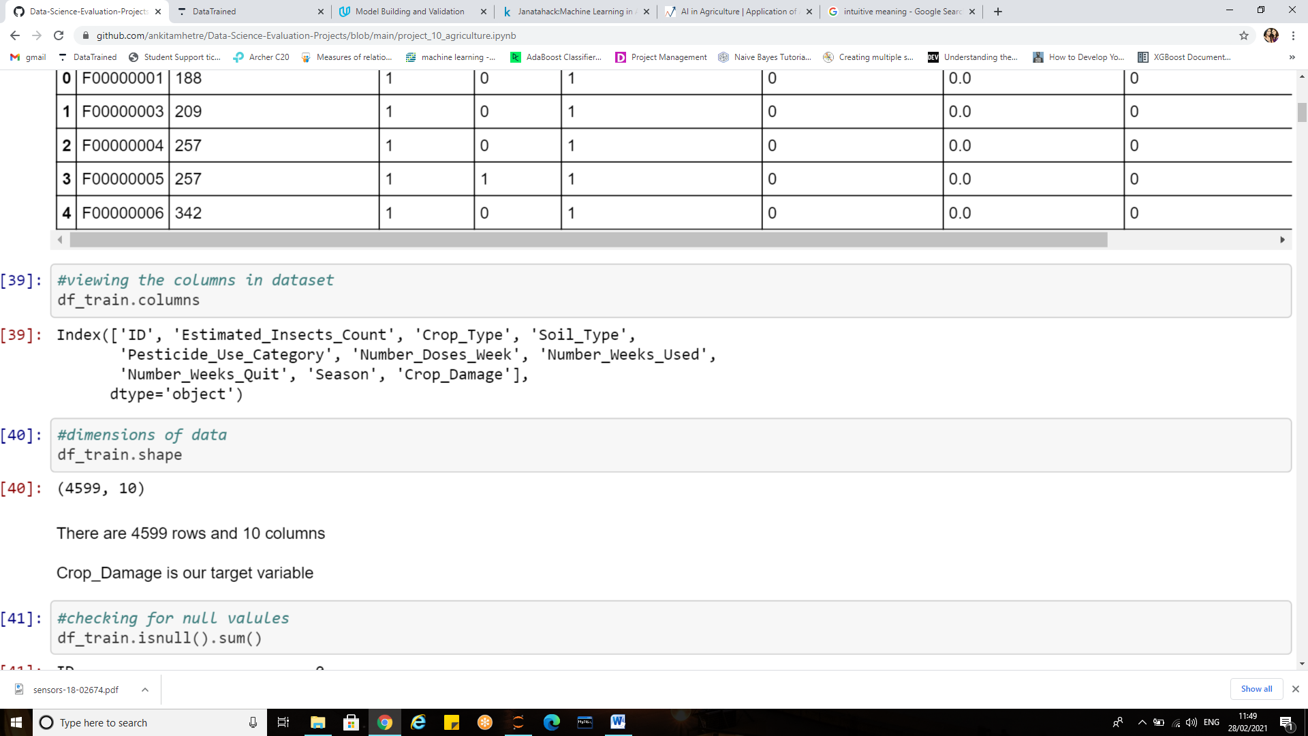

**df_train.shape**: returns a tuple representing the dimensionality of the dataframe.

The dataset has 4599 rows and 10 columns

**Df_train.columns** attribute returns the column labels of the Dataframe.

There are 9 features (independent variables) and 1 target variable i.e. Crop_Damage

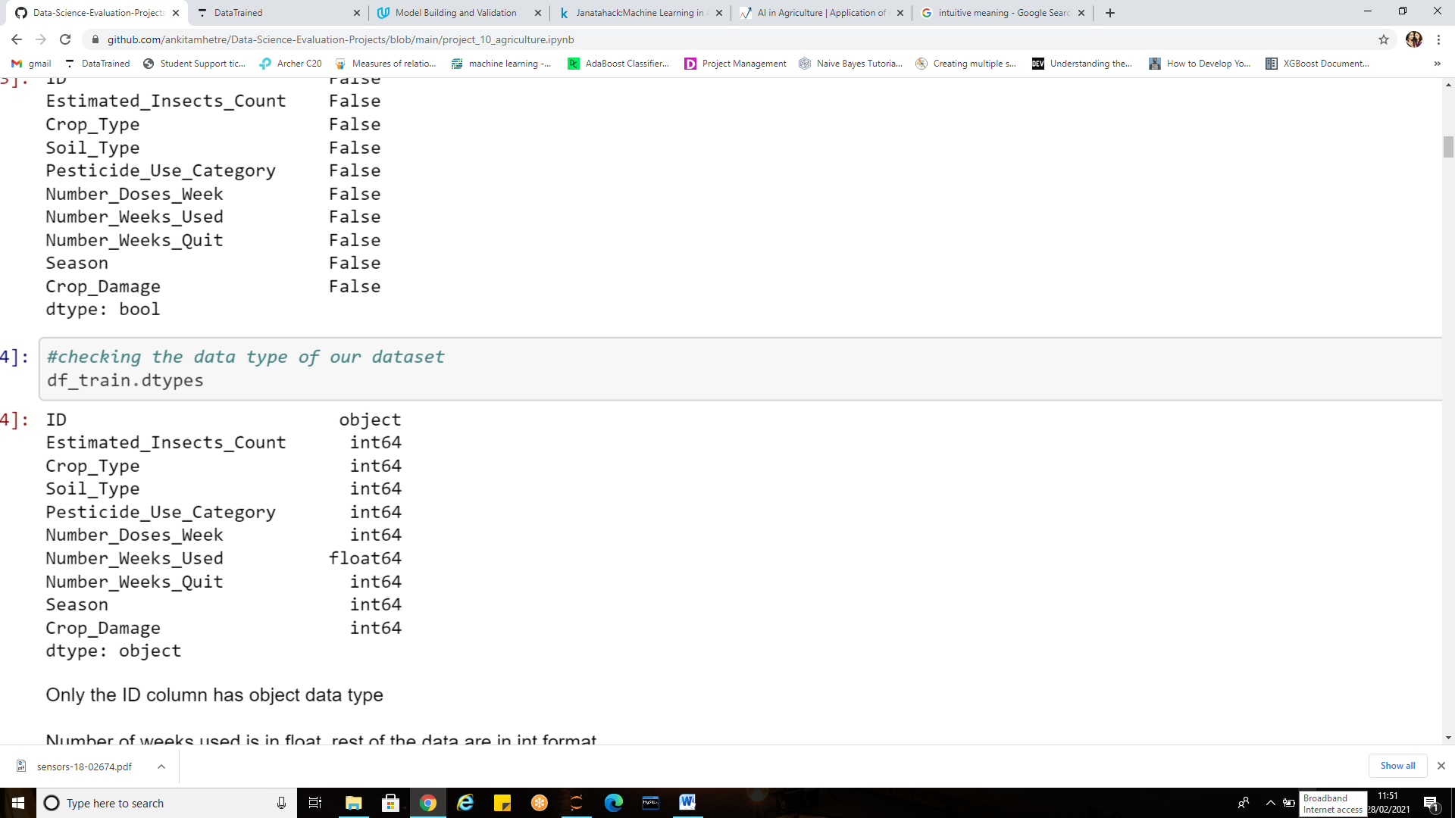

**df_train.dtypes** attribute returns the dtypes in the DataFrame. It returns a Series with the data type of each column.

It can be seen that only ‘Id’ column is object type ,rest of the columns are int Number_of_weeks_used is float type.

**df_train.info()** method can be used to print information about a DataFrame including the index dtype and columns, non-null values and memory usage.

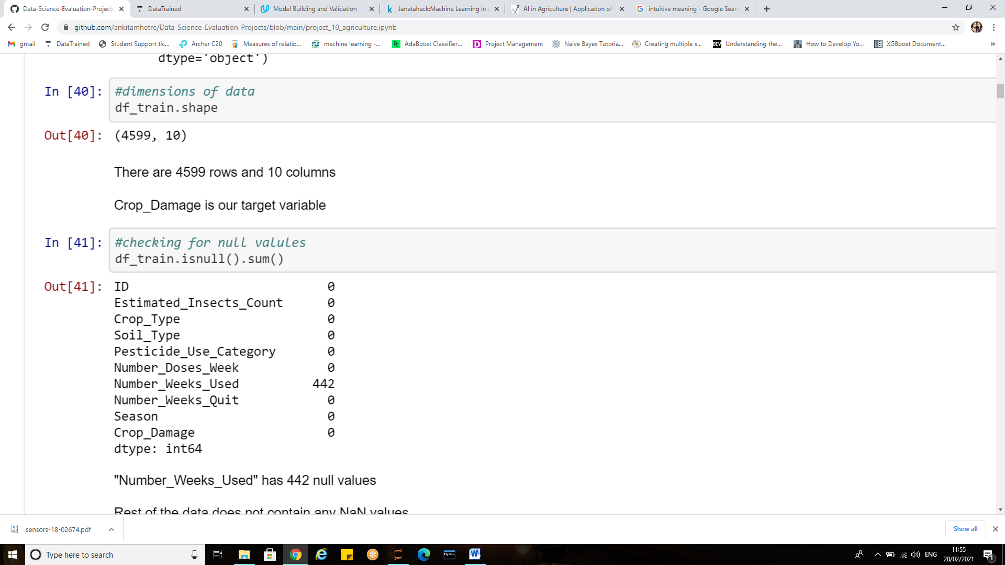

**isnull(). sum()** returns the number of missing values in the data set. The data has NaN values in number of weeks used column.

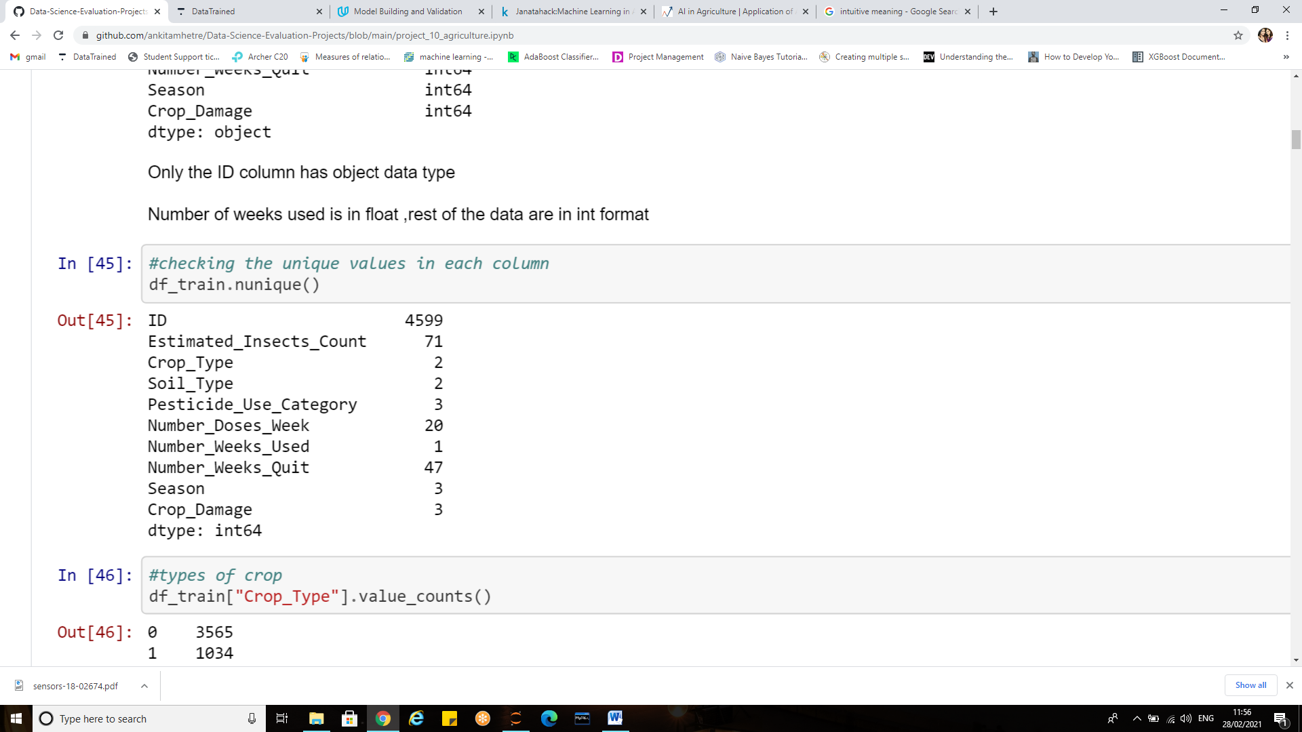

**nunique()** function return number of unique elements in the object. It returns a scalar value which is the count of all the unique values in the Index. By default the NaN values are not included in the count.

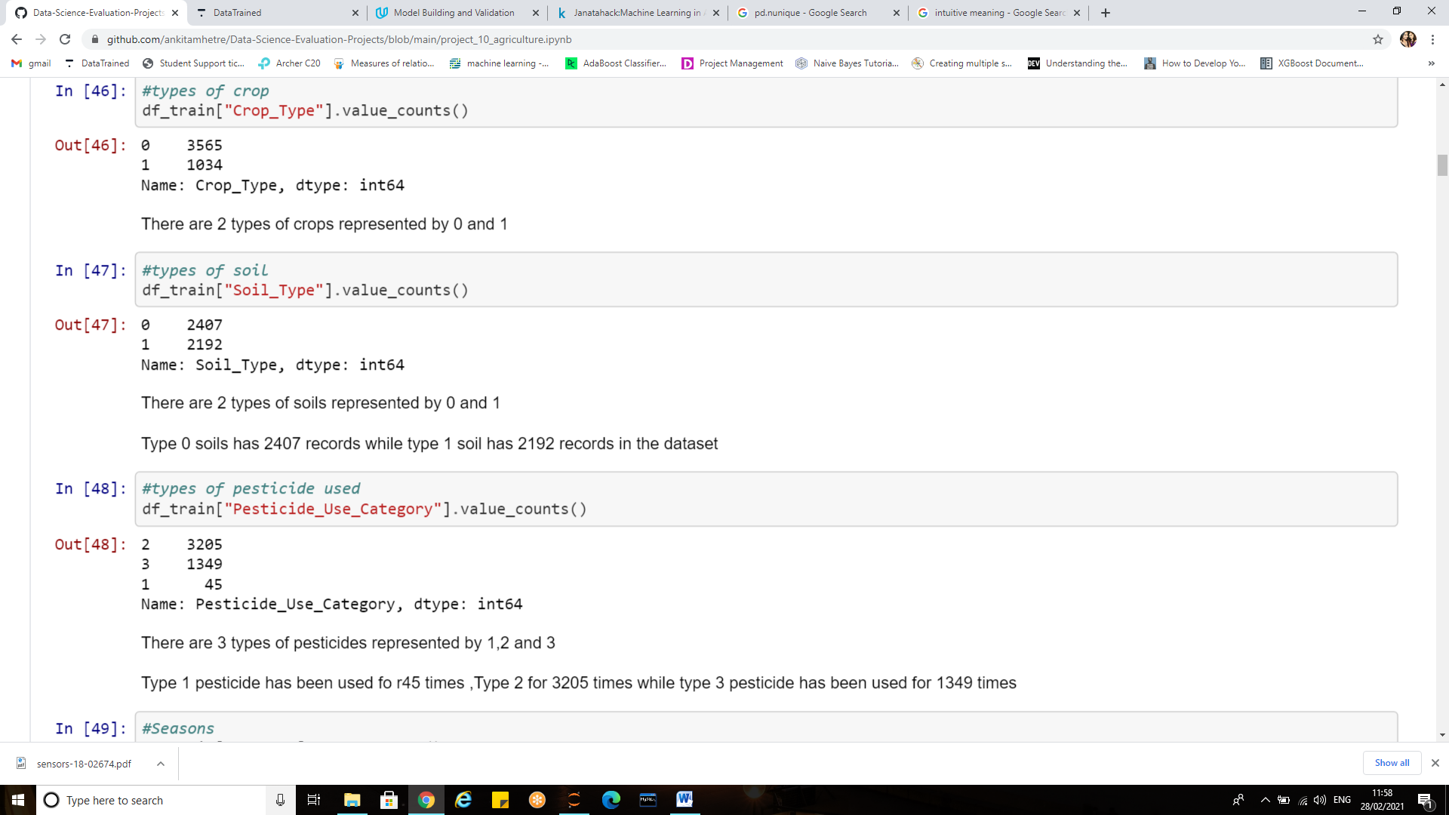

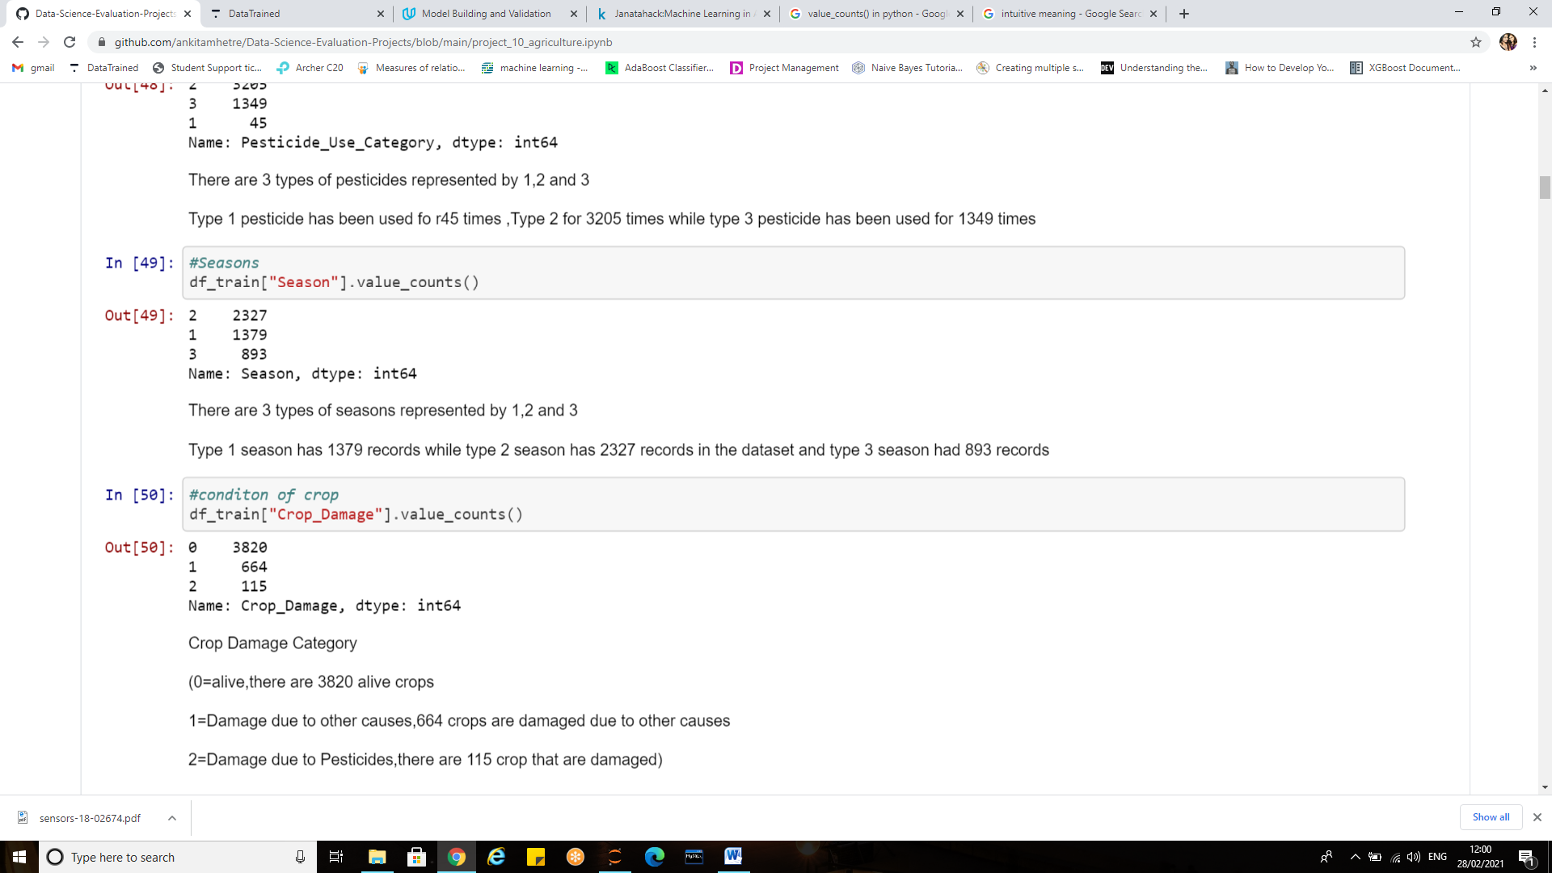

**value_counts()** function returns object containing counts of unique values. The resulting object will be in descending order so that the first element is the most frequently-occurring element. Excludes NA values by default.

For our dataset all the unique value counts are described in markdown cell.

***“It’s really powerful to have somebody who can come in and be like, ‘I can do all of this data analysis, but also I understand enough to know how to do it responsibly and communicate with different stakeholders.’”***

**Visualizations:**

Do you have a keen eye for color and design? Can you summarize complex data in a few simple charts?

If you answer yes to those questions, then you just might be a good fit for data visualization.

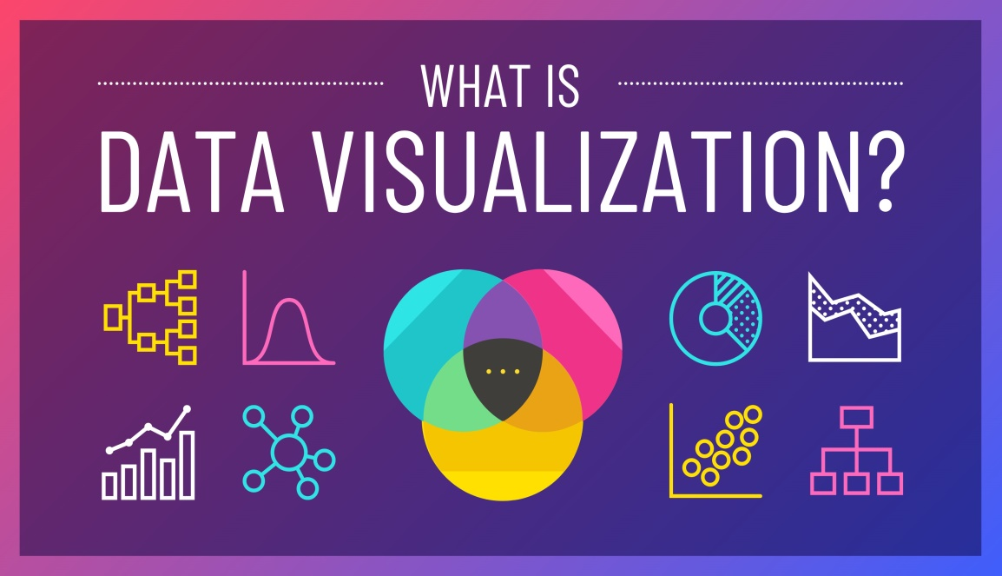

Data visualization is all about telling a story with data. As a data scientist, we should always be keen to perform the visualizations.

We should put more emphasis and efforts into ensuring a thorough analysis rather than just making the graphs pretty and investing lot of time in just decorating them .Prettier graphs won’t necessarily mean great analysis.

Data analysis and data visualization are not entirely exclusive work sets – they co-exist and feed off of each other.

In the journey from analysis to data-driven outcomes, data visualization plays a very important role of presenting data in a powerful and credible way.

***Thus Data visualization is an art that data scientists need to be good at in order to tell a compelling story from their analysis***

**Data visualization in python:**

It becomes easier to grasp difficult concepts or identify new trends we may have missed. We can use data visualizations to make an argument, or to support a hypothesis, or to explore our world in different ways. Python allows us to create visualizations easily and quickly using libraries such as Matplotlib, Pandas visualization and Seaborn.

**Matplotlib**

Matplotlib is the most popular python plotting library. It is a low-level library with a Matlab like interface which offers lots of freedom at the cost of having to write more code. Matplotlib is specifically good for creating basic graphs like line charts, bar charts, histograms and many more.

**Pandas Visualization**

Pandas is an open source high-performance, easy-to-use library providing data structures, such as dataframes, and data analysis tools like the visualization tools we will use in this article.

Pandas Visualization makes it really easy to create plots out of a pandas dataframe and series. It also has a higher level API than Matplotlib and therefore we need less code for the same results.

Importing the libraries for visualizations 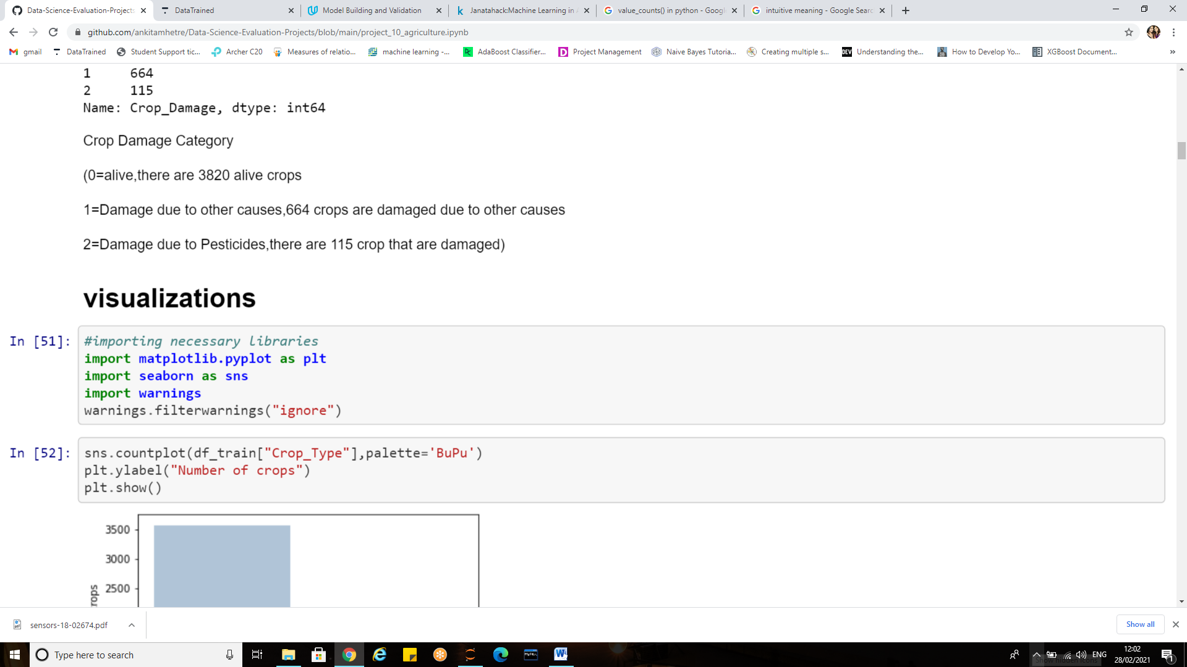

In Seaborn a bar-chart can be created using the sns.countplot method and passing it the data.

**Sns.countplot ():** Shows the counts of observations in each categorical bin using bars.

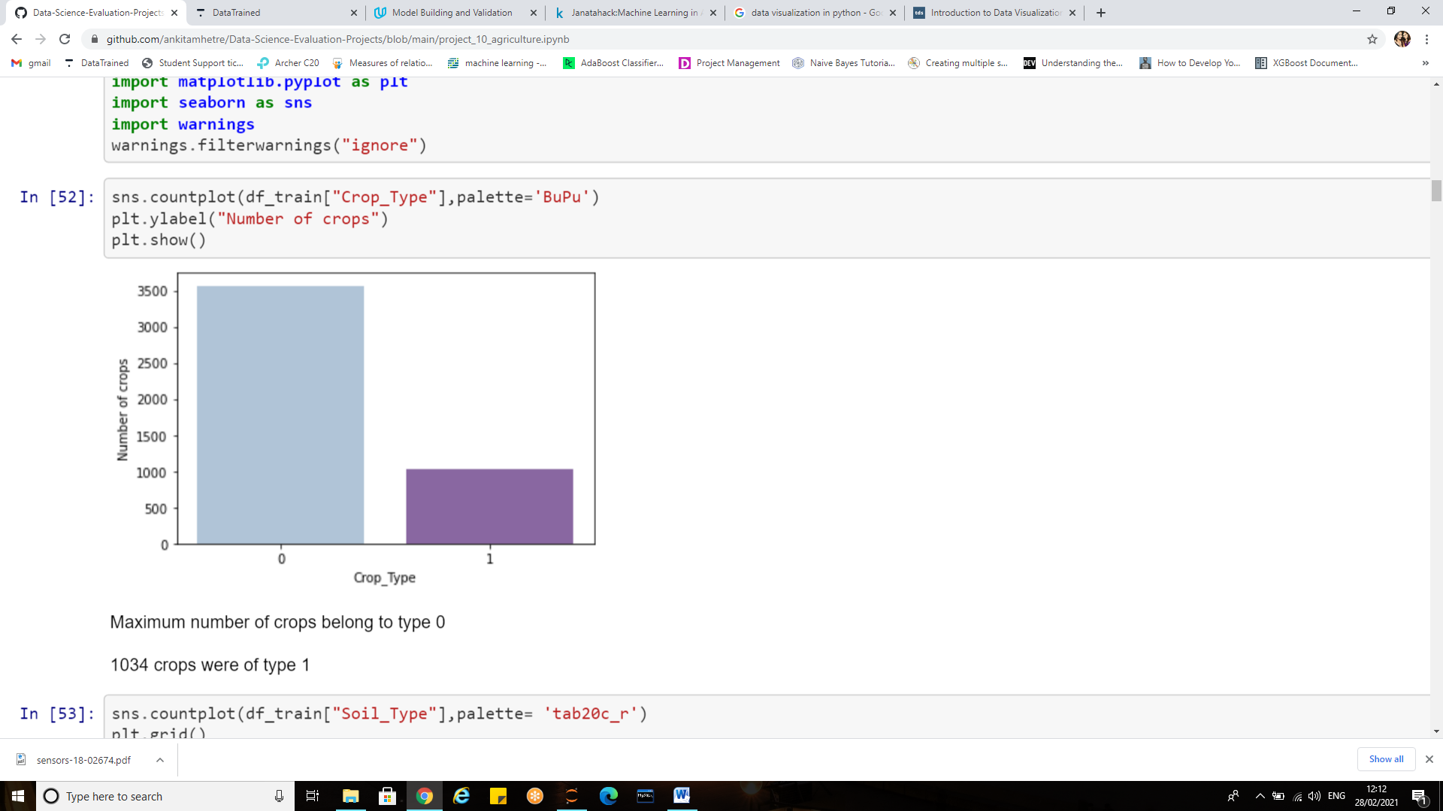 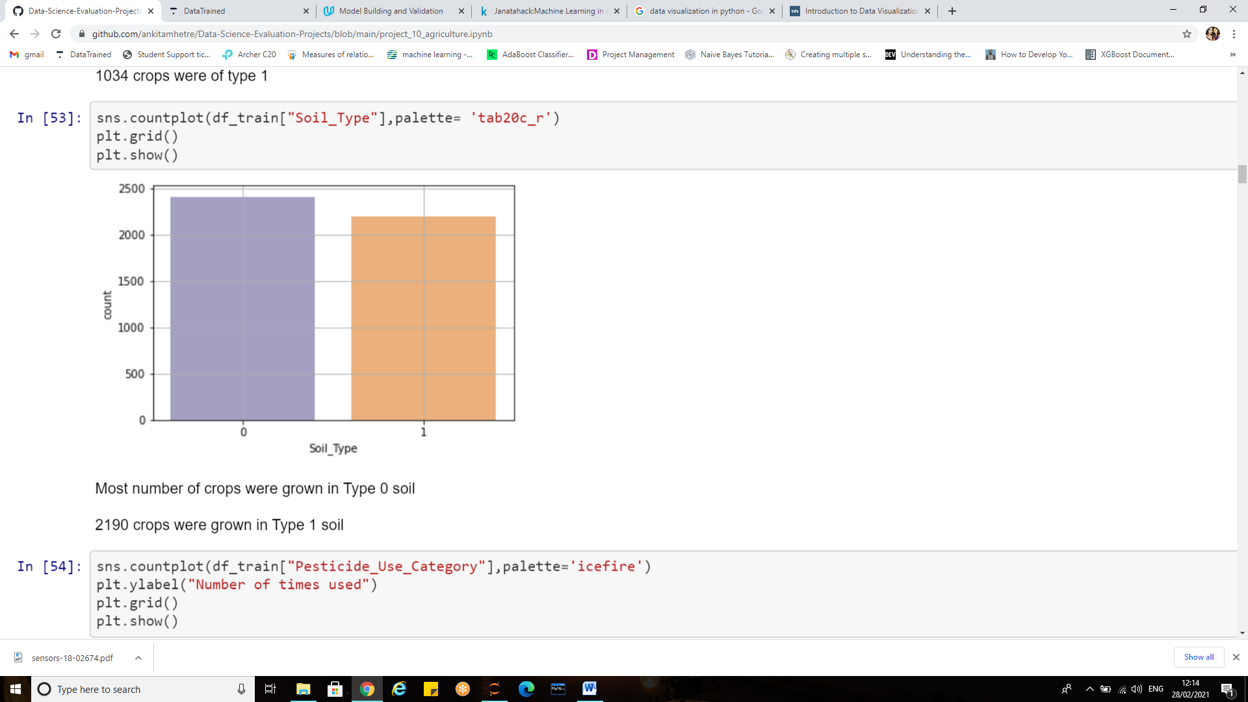

**Crop_Type**:

* Maximum number of crops belong to type 0
* 1034 crops were of type 1

**Soil_type:**

* Most number of crops were grown in Type 0 soil
* 2190 crops were grown in Type 1 soil

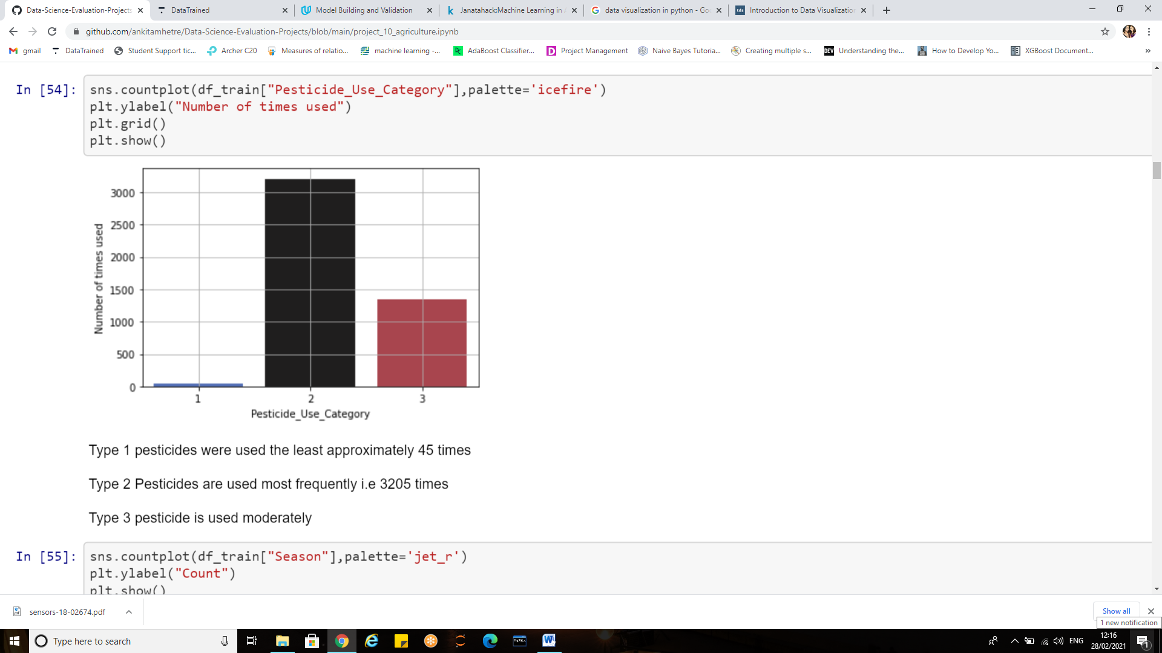 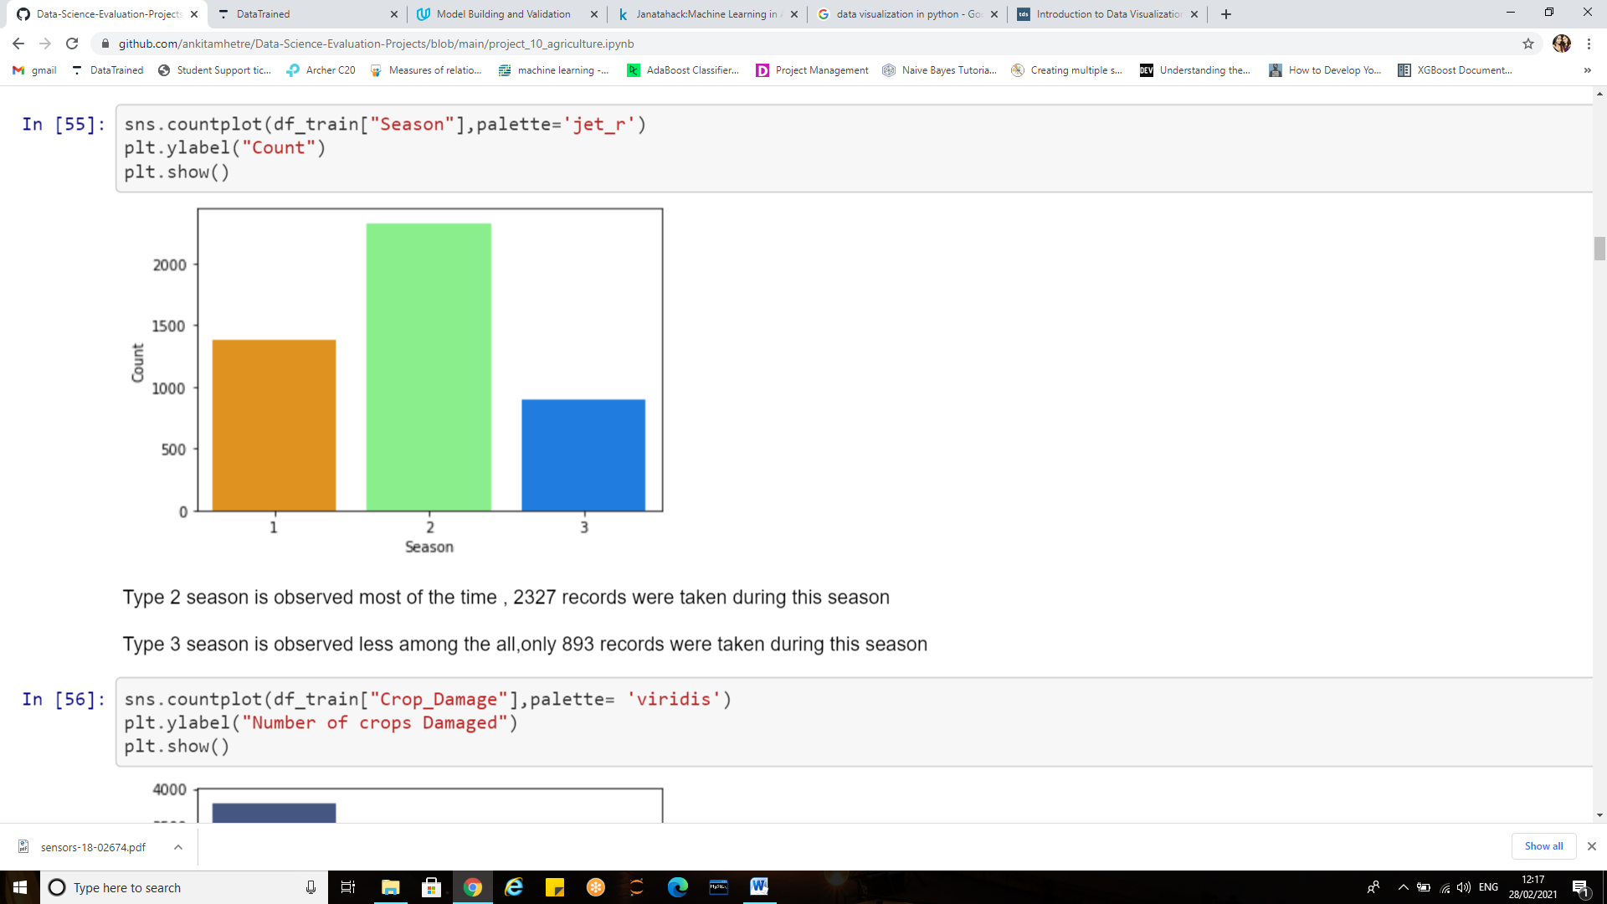

**Pesticide_use_category:**

* Type 1 pesticides were used the least approximately 45 times
* Type 2 Pesticides are used most frequently i.e. 3205 times
* Type 3 pesticide is used moderately

**Season:**

* Type 2 season is observed most of the time , 2327 records were taken during this season
* Type 3 season is observed less among the all, only 893 records were taken during this season

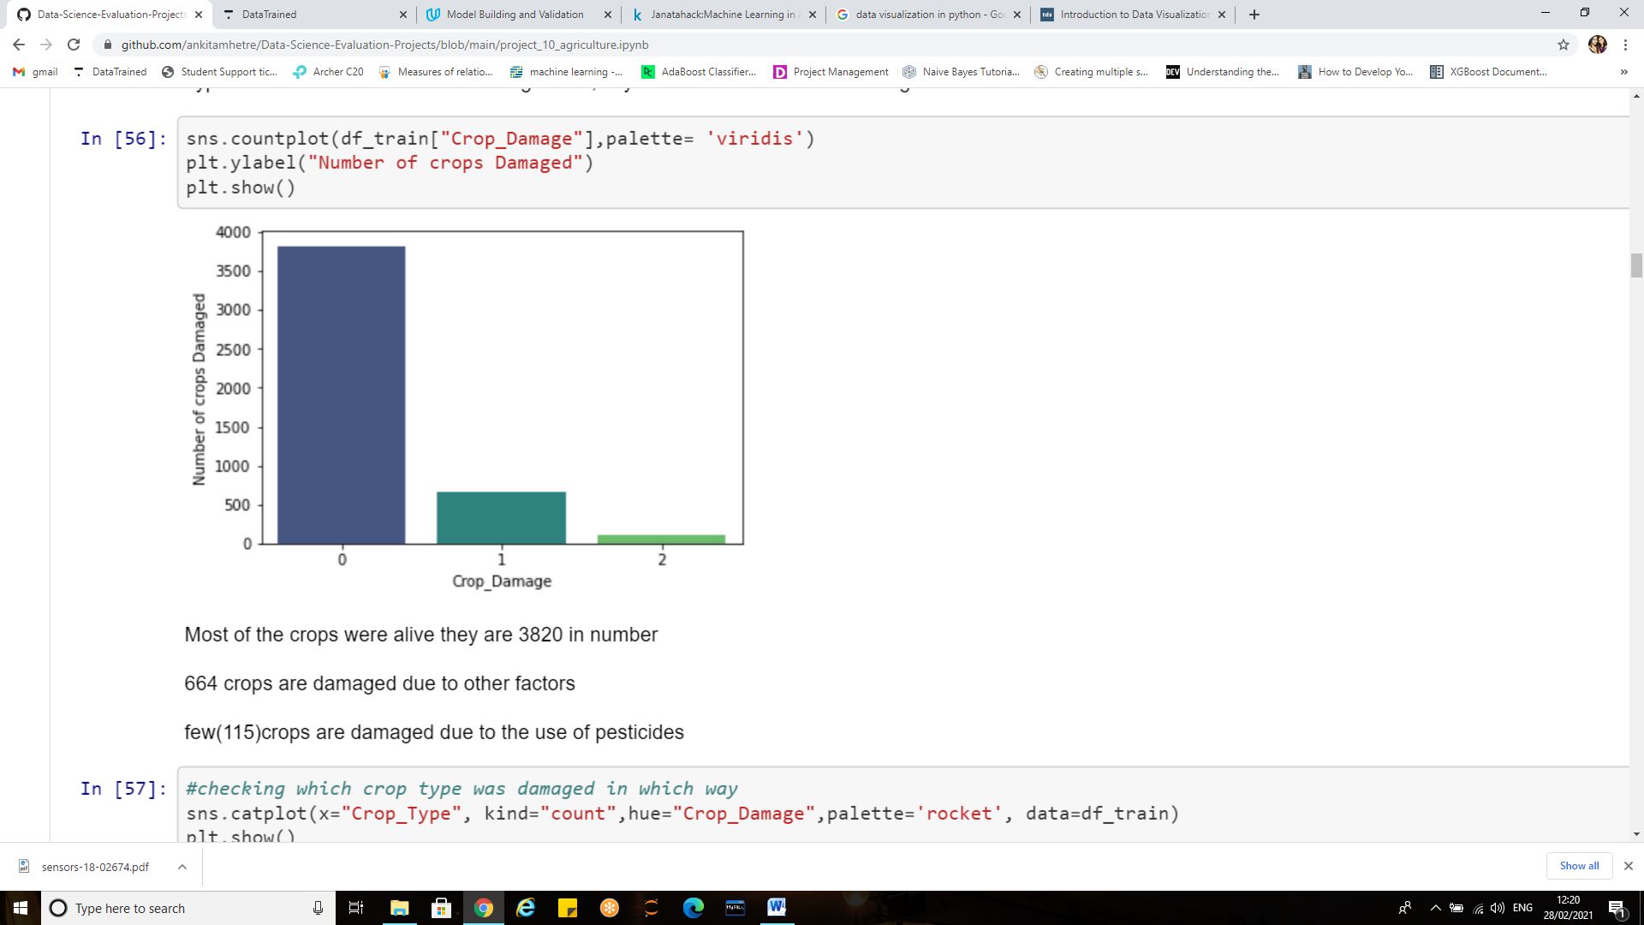

**Crop damage:**

Most of the crops were alive they are 3820 in number

664 crops are damaged due to other factors.

few(115)crops are damaged due to the use of pesticides

**sns.catplot**

This function provides access to several axes-level functions that show the relationship between a numerical and one or more categorical variables using one of several visual representations. The kind parameter selects the underlying axes-level function to use:

palette: colours to use for the different levels of the hue variable.

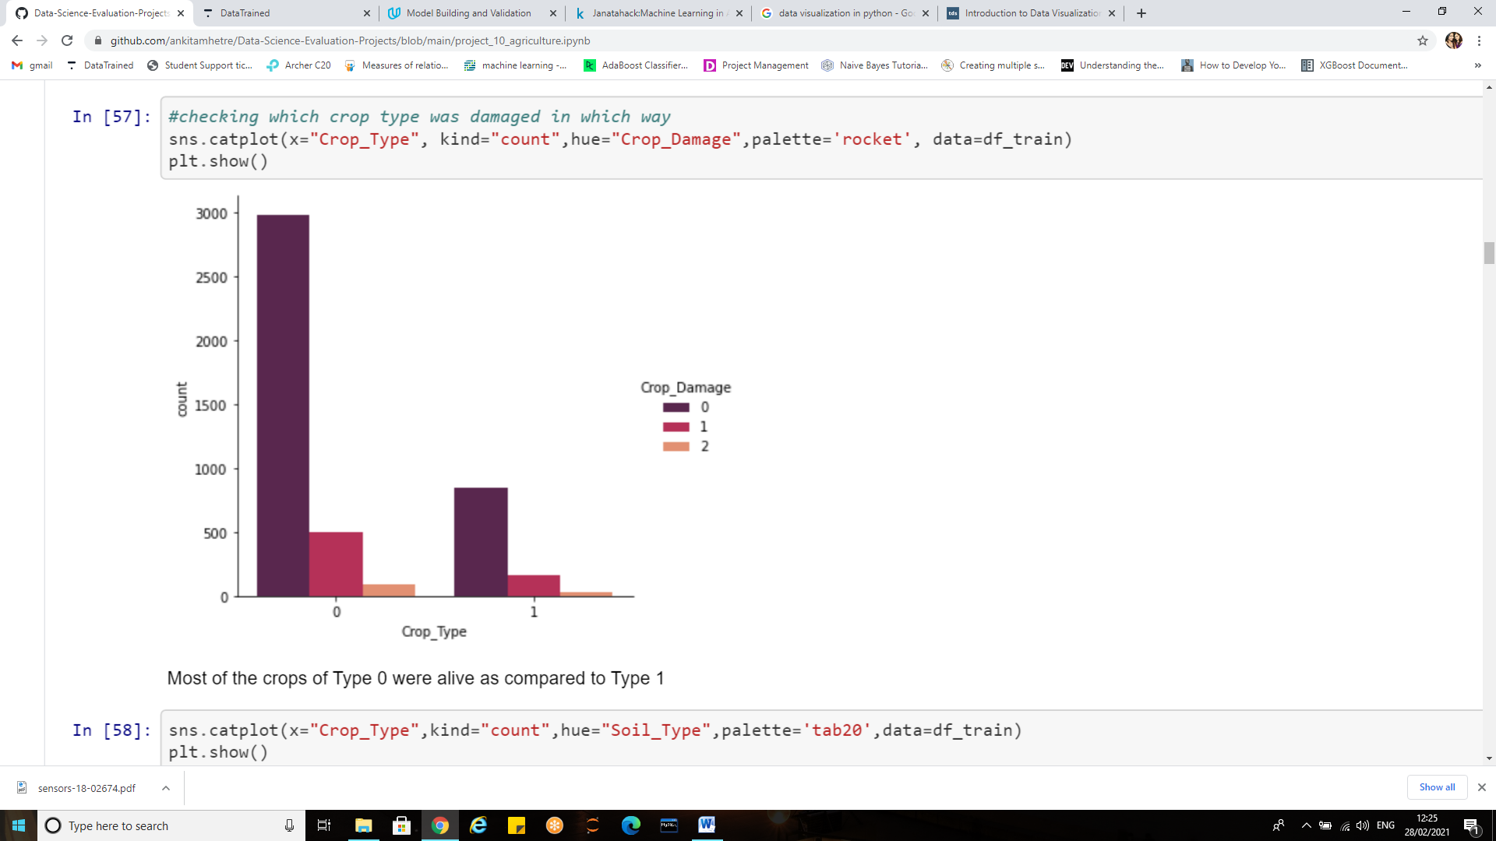

Most of the crops of Type 0 were alive as compared to Type 1

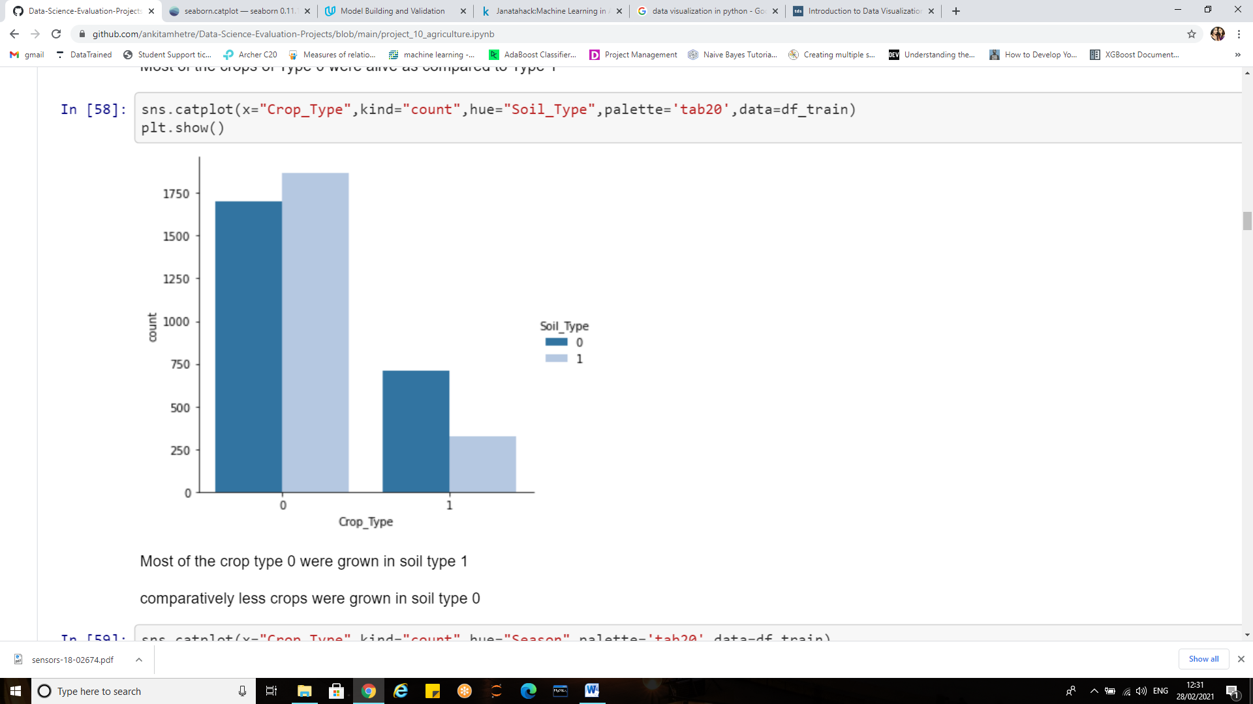

Most of the crop type 0 were grown in soil type 1

Comparatively fewer crops were grown in soil type 0

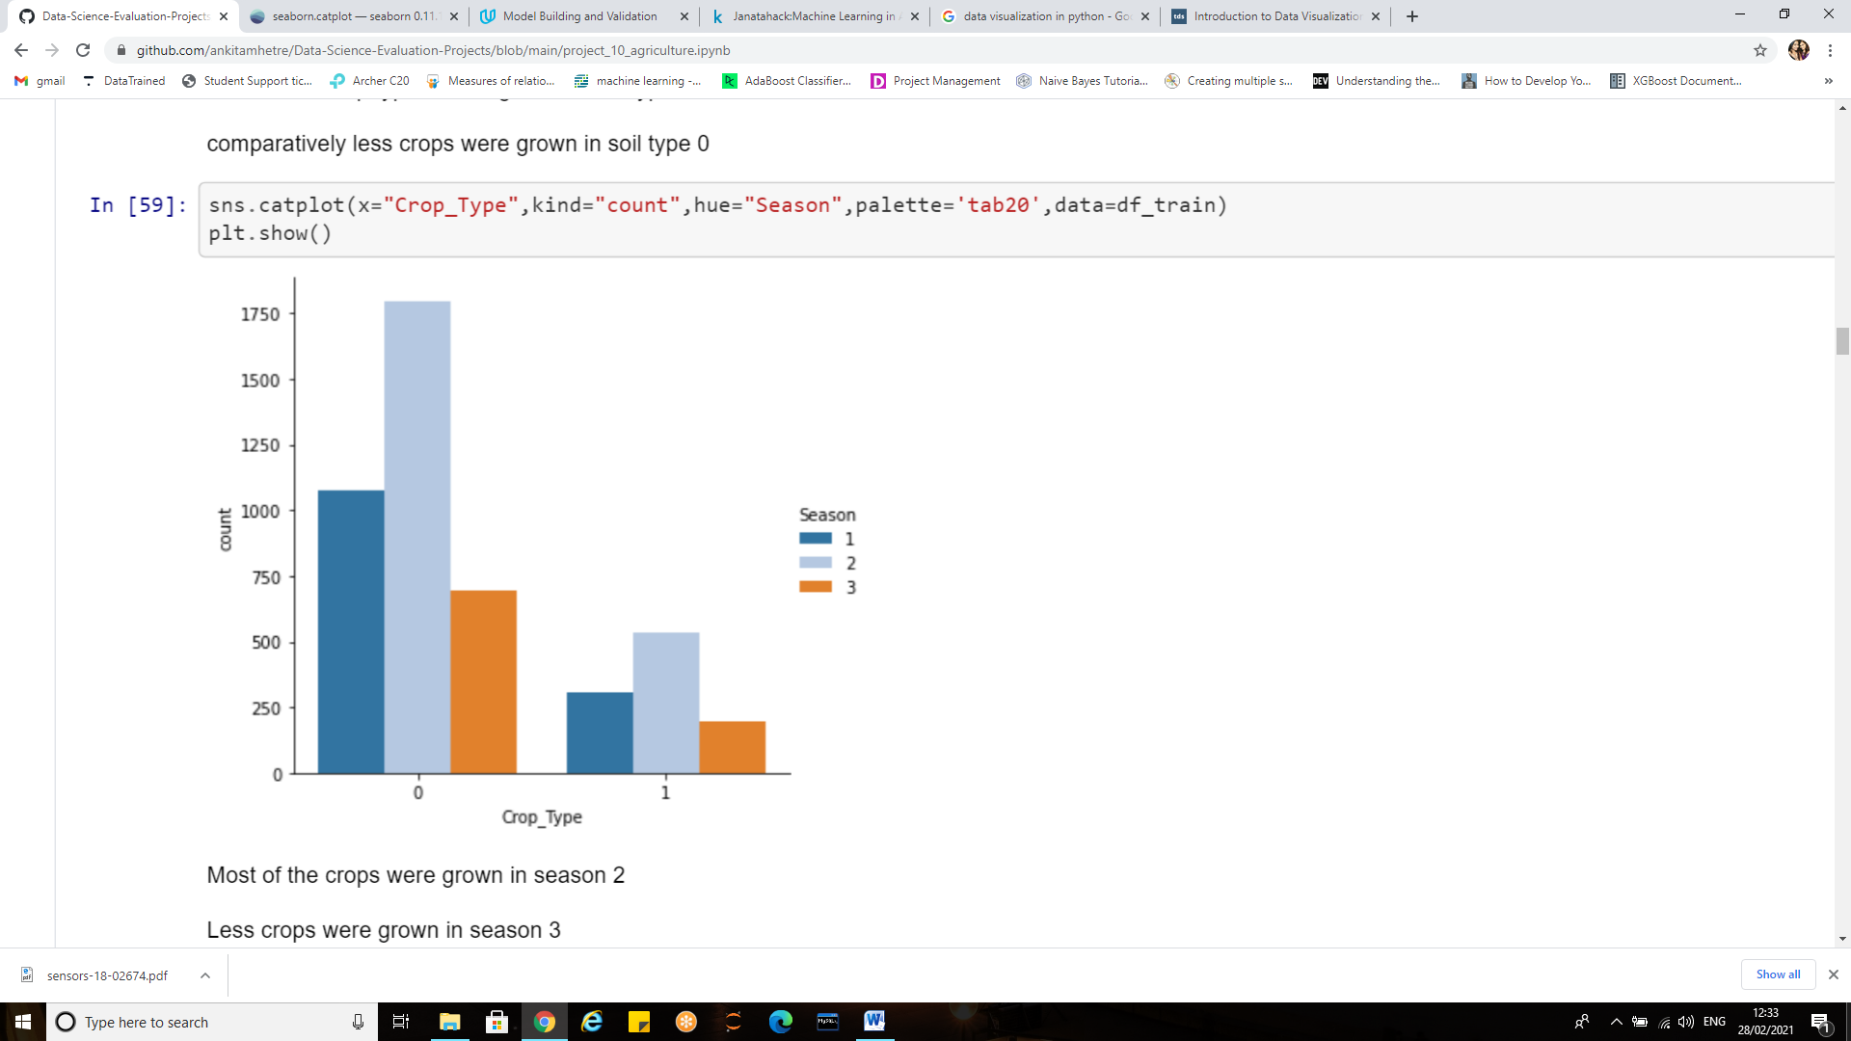

Most of the crops were grown in season 2

Fewer crops were grown in season 3

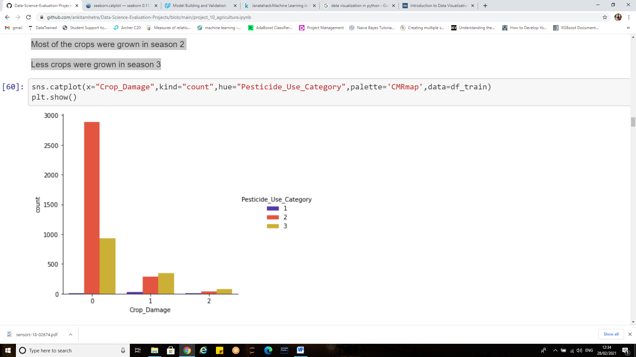

When pesticide 2 was used most of the crops were alive

Pesticide 3 resulted in damaged crops.

**Histogram:**

A [histogram](https://en.wikipedia.org/wiki/Histogram) is a representation of the distribution of data. For the numerical columns in our dataset hist plot is made. Subplot will result in multiple plots in a single row

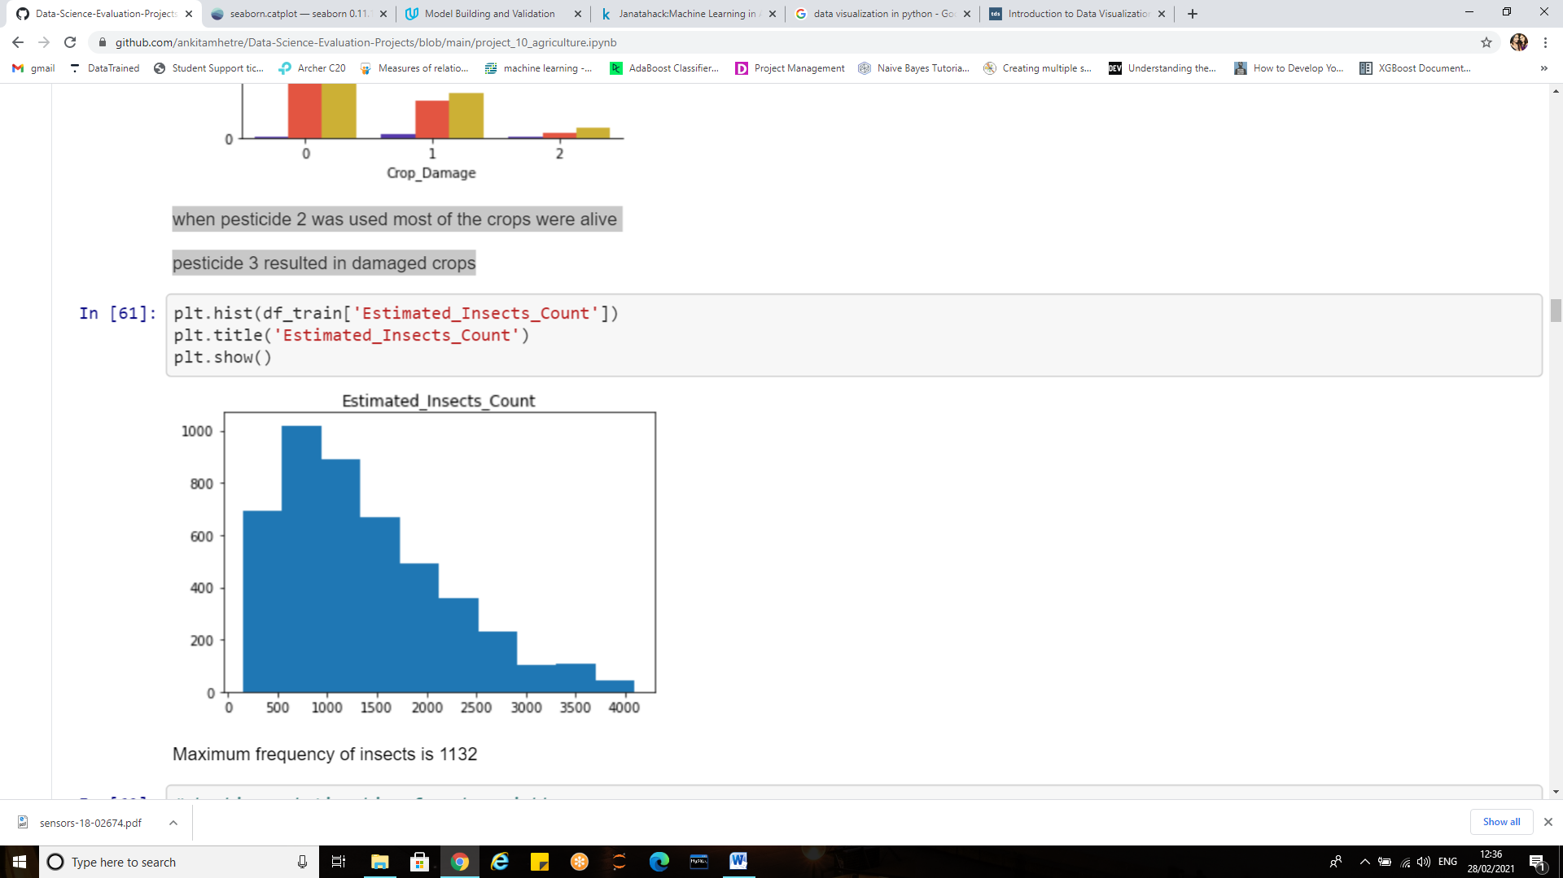

Maximum frequency of insects is 1132 for insects between 500 to 1000

**Bivariate Analysis using pair plot:**

A pair plot allows us to see both distribution of single variables and relationships between two, it enables us to plot a grid of pairwise relationships in a dataset. The diagonal of the graph is filled with histograms and the other plots are scatter plots.

Pair plots are a great method to identify trends for follow-up analysis and, fortunately, are easily implemented in Python!

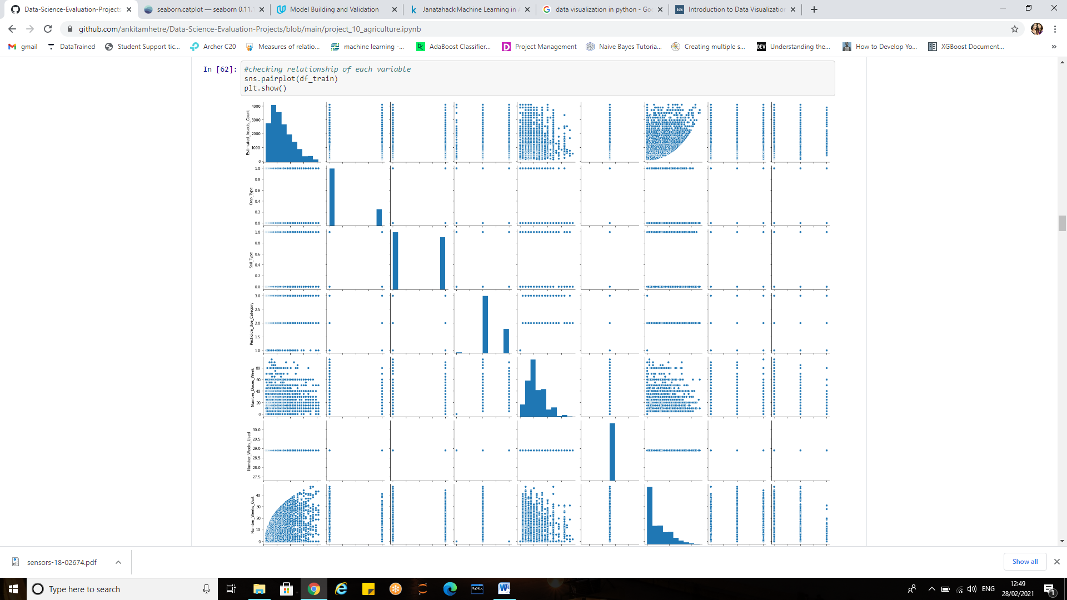

**Box plot:**

A Box Plot is also known as **Whisker plot** is created to display the summary of the set of data values having properties like minimum, first quartile(25th percentile), median(50th percentile), third quartile(75th percentile) and maximum.

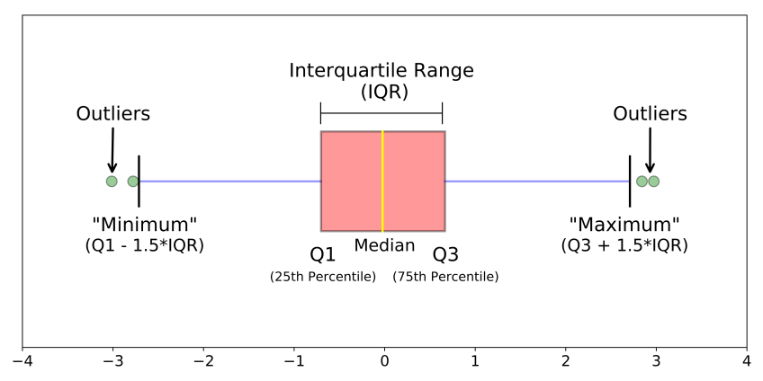

Box plot tells us about outliers and what their values are. It can also tell if data is symmetrical, how tightly the data is grouped, and if and how data is skewed.

We can create box plots using seaborns sns.boxplot method and passing it the data as well as the x and y column name.

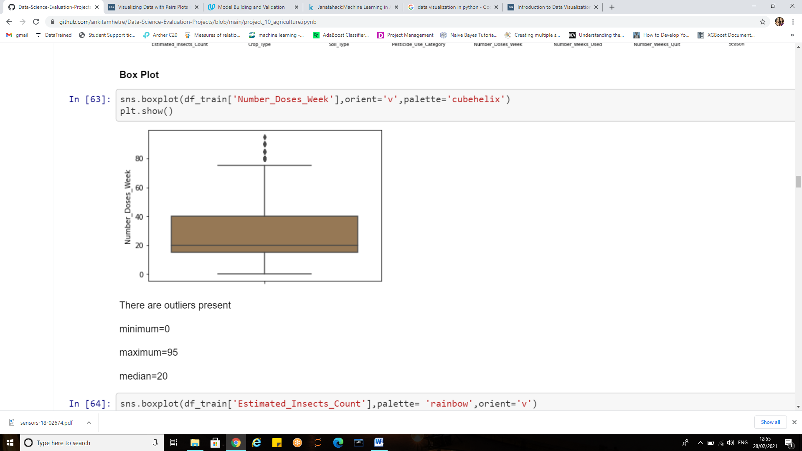

**Observations:**

* There are outliers present in number of doses per week
* minimum=0
* maximum=95
* median=20

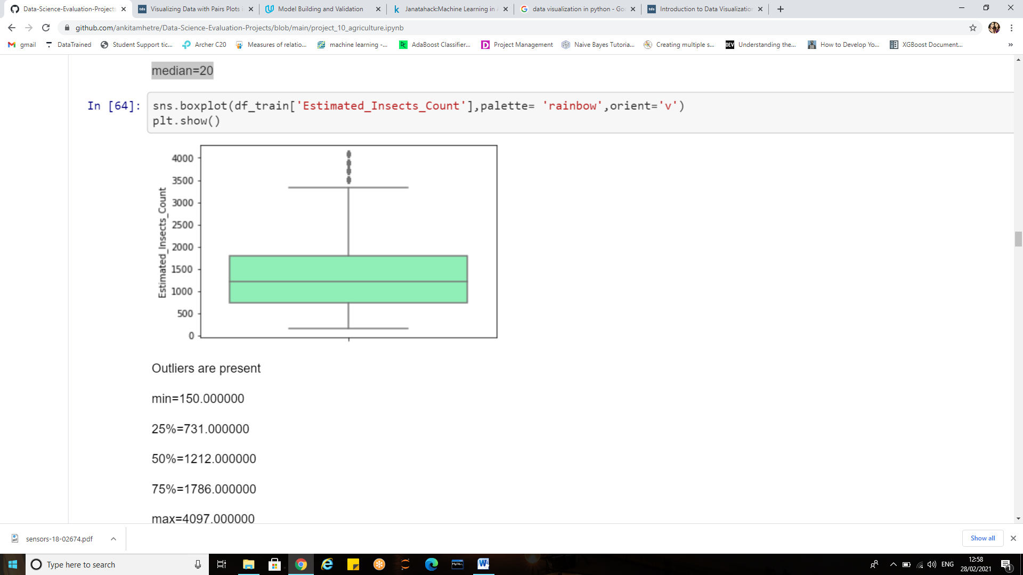

**Observations:**

* Outliers are present
* min=150.000000
* 25%=731.000000
* 50%=1212.000000
* 75%=1786.000000
* max=4097.000000

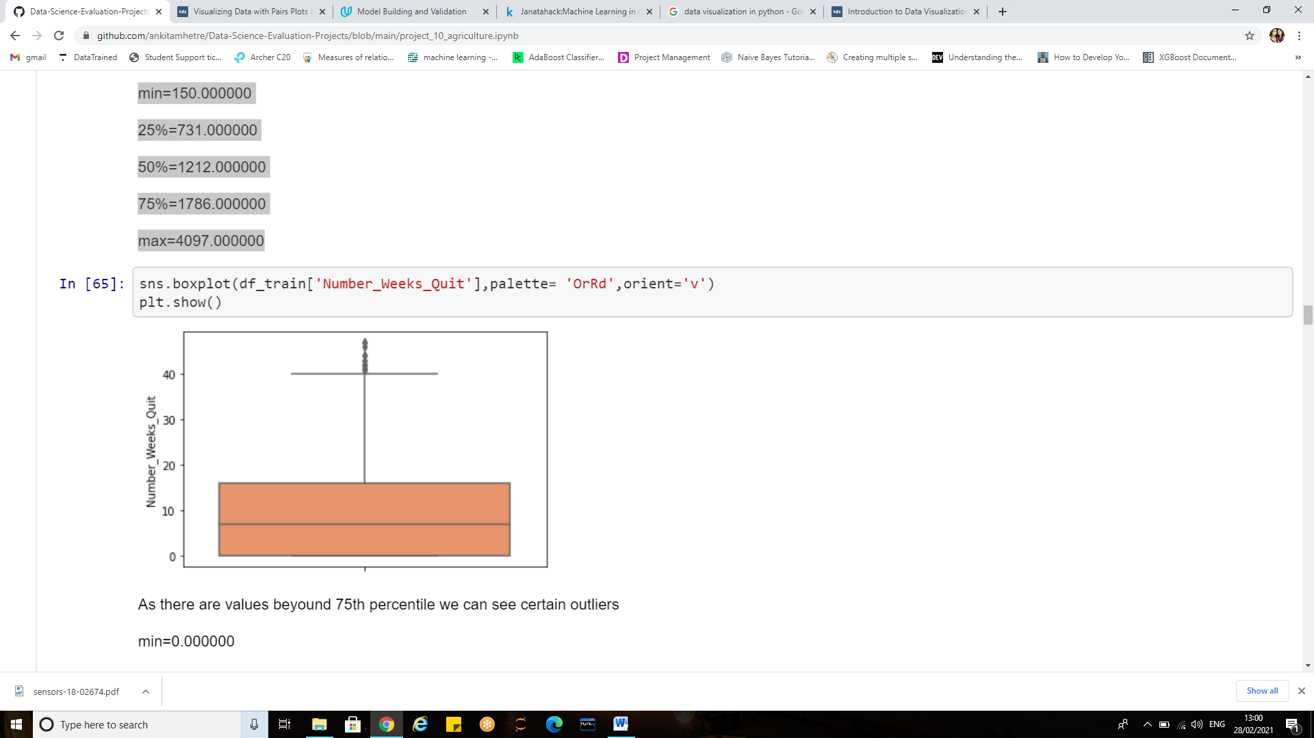

**Observations:**

* As there are values beyond 75th percentile we can see certain outliers
* min=0.000000
* 25% =0.000000
* 50%=7.000000
* 75%=16.000000
* max =47.000000

**Statistical Analysis:**

To get the correlation of the features inside a dataset we can call <dataset>.corr(), which is a Pandas dataframe method. This will give us the correlation matrix.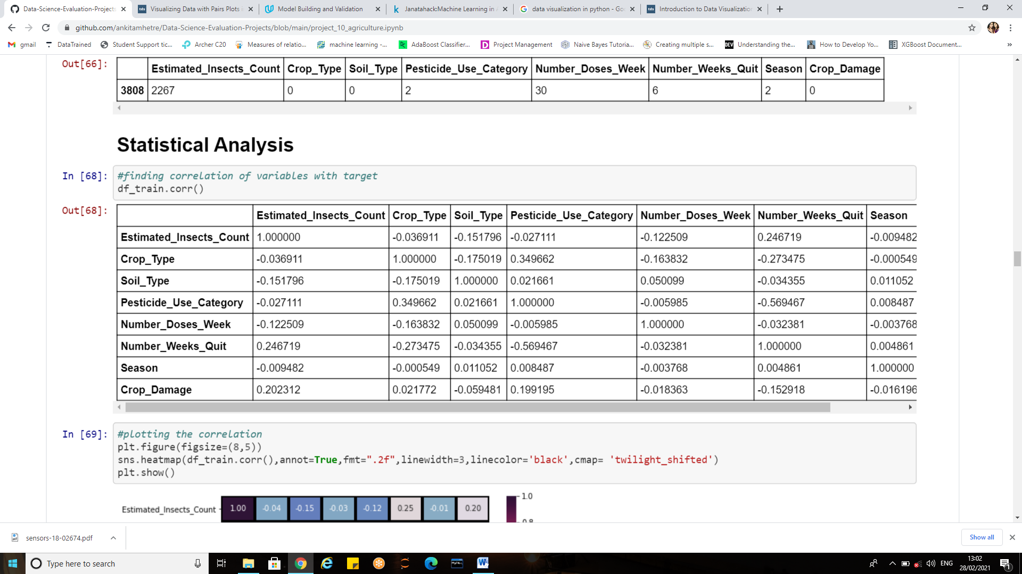

We can visualize the correlation matrix using a heatmap in seaborn.

A **Heatmap** is a graphical representation of data where the individual values contained in a matrix are represented as colors. Heatmaps are perfect for exploring the correlation of features in a dataset.

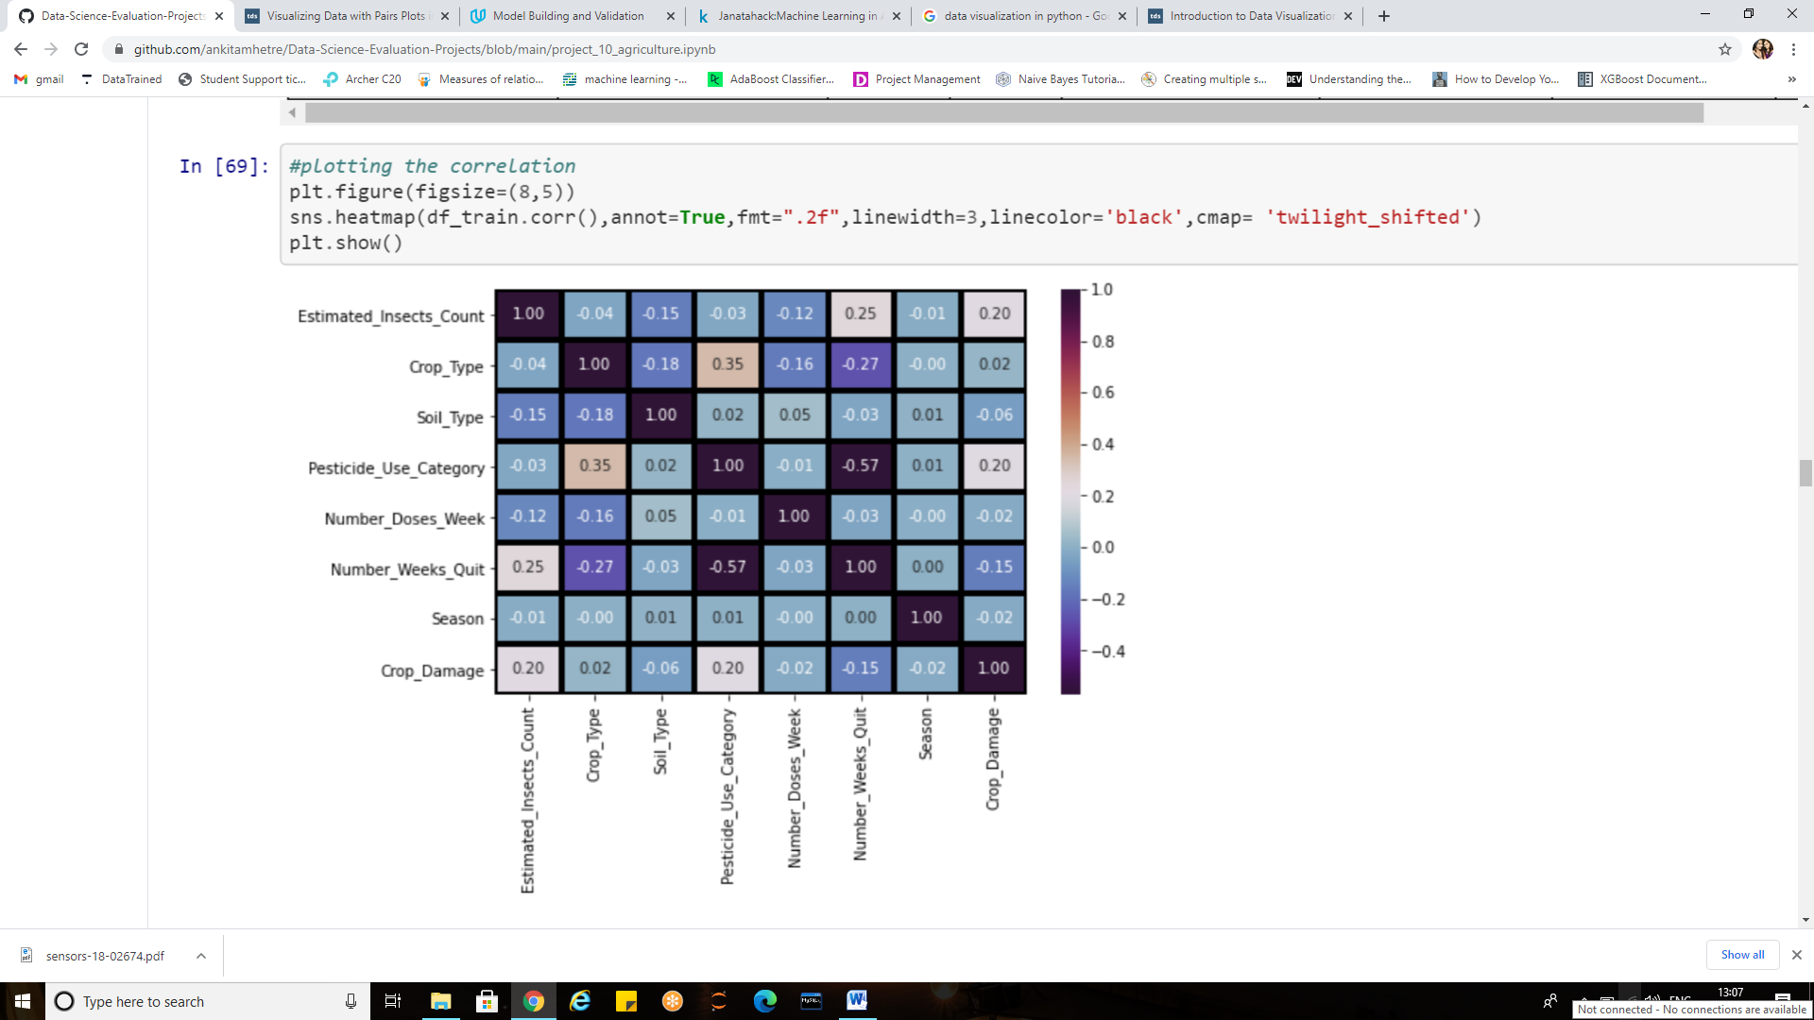

Dark shades represent positive correlation while lighter shades represent negative correlation.

Setting **annot=True**, we’ll get values by which features are correlated to each other in grid-cells.

**Fmt** is the String formatting code to use when adding annotations.

**Linewidth** is the width of the lines that will divide each cell.

**linecolor**, Color of the lines that will divide each cell.

**Observations**

* "Estimated_Insects_Count" and "Pesticide_use_category" has the highest positive correlation of 0.20 with target variable.
* "Soil_type" has the least correlation which is -0.06
* "crop_types" has the least positive correlation
* "Number_doses_week" and "season" has correlation of -0.02

Where the correlation is zero we can infer there is no linear relationship between the predictors and the target.

**Pandas.describe():**

Pandas describe() is used to view some basic statistical details like percentile, mean, standard deviation etc. of a data frame or a series of numeric values.

As shown in the output image, Statistical description of DataFrame is returned with the respective percentiles.

If there are the columns with strings, NaN will be returned for numeric operations. As the dataset here contains no string values NaN’s are not present.

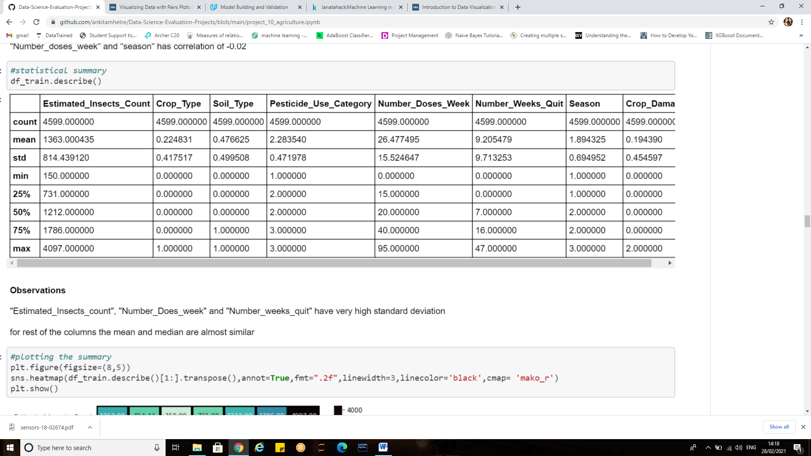

**df.describe(include='all')** can be used to describe all columns of a DataFrame regardless of data type.

#### Observations:

#### Columns with high standard deviation

* "Estimated_Insects_count",
* "Number_Does_week"
* "Number_weeks_quit"

Here as we can notice mean value is almost similar to the median value of each column which is represented by 50% (50th percentile) in index column.

There is notably a large difference between 75th percentile and max values of predictors ‘estimated insects count’, and ‘number of weeks quit’.

Thus for the observations where there is a difference between minimum value and 25th percentile, and 75th percentile and maximum value suggests that there are outliers present in our data set.

A heatmap can also be visualized for the describe method as shown below:

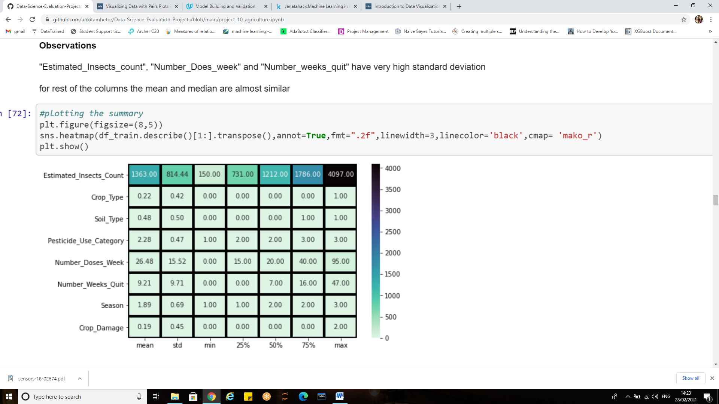

**Cmap**: it is the colormap, used for mapping data values to color space.

**.transpose ():** Reflect the Data Frame over its main diagonal by writing rows as columns and vice-versa. E.g. If we have an array of shape (X, Y) then the transpose of the array will have the shape (Y, X).

**Z-scores for Outlier Detection**:

A critical part of the EDA is the detection and treatment of outliers. **Outliers**are observations that deviate strongly from the other data points in a random sample of a population. Z-scores are a way to compare results to a “normal” population

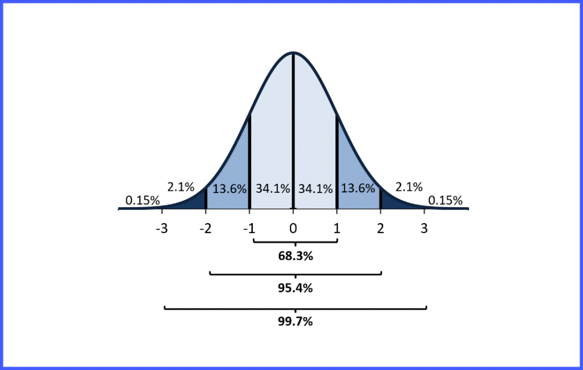

Emperial Rule and Z-score Probability

The z score tells you how many standard deviations from the mean your score is.

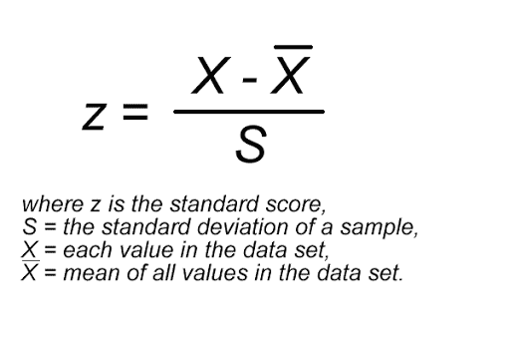

The empirical rule tells you what percentage of your data falls within a certain number of standard deviations from the mean:

• 68% of the data falls within one standard deviation of the mean. i.e. 1SD  
• 95% of the data falls within two standard deviations of the mean.i.e.2SD  
• 99.7% of the data falls within three standard deviations of the mean.i.e. 3SD

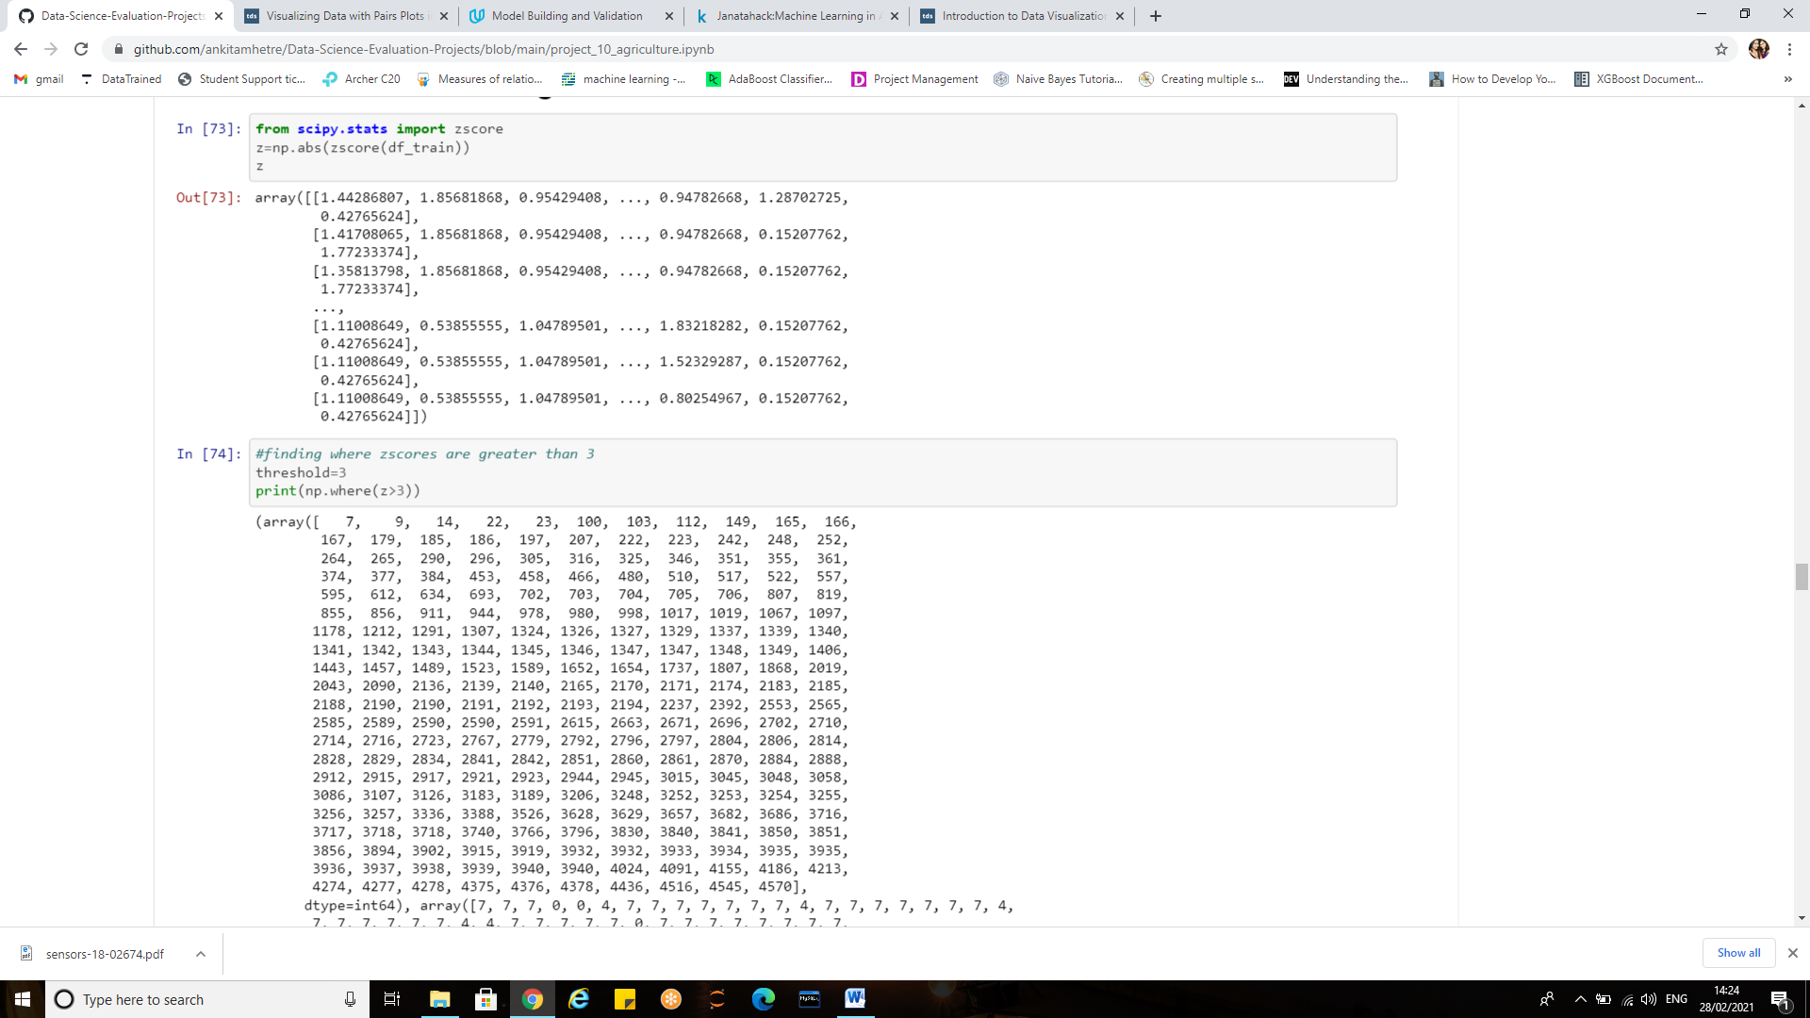

If the z score of a data point is more than 3, it indicates that the data point is quite different from the other data points. Such a data point can be an outlier.

Zscore(df_train) will give us the z scores the threshold has been set to 3 as the values above 3 are treated as outliers.

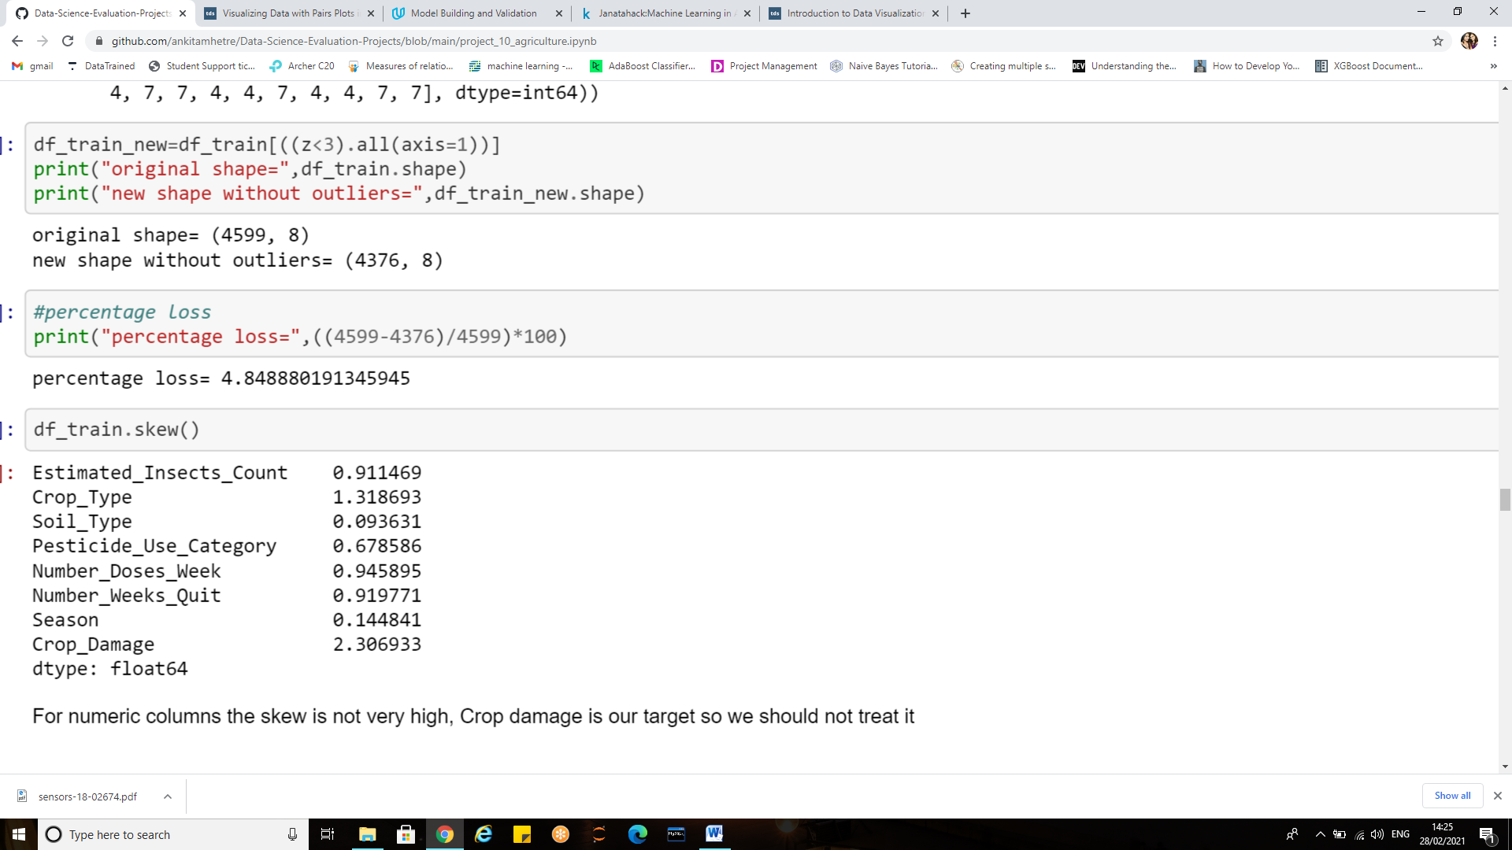

The new shape without outliers results in 4.84% of data loss hence prefer not to drop those records as it may affect the overall performance of model as the data is already less.

**EDA Concluding Remarks:**

From the above EDA we can infer that successful farming comes down to making complex decisions based on interconnections of a multitude of variables, including crop specifications, soil conditions, climate change, seasons , used pesticides and many more.

Statistics and probability is used to figure out trends in data set. The data distribution, skewness, correlation is checked.

Some of the key observations are:

* Estimated insects count and the type of pesticides used had a great impact on the quality of crop harvested.
* The amount of crops harvested varies from season to season.
* Most of the crops were damaged due to other external factors rather than pesticides

***To sum up all, Exploratory Data Analysis is a philosophical and an artistic approach to gauge every nuance from the data at early encounter****.*

**Pre-processing pipeline:**

Cleaning data is most of the work – Knowing where to find the right data, how to access the data, and how to properly format/standardize the data is a huge task. It usually takes more time than the actual analysis. Research shows that data cleaning and preparation accounts for around 80% of the work of data professionals. This makes it perhaps the key skill for anyone serious about data science.

Data pre-processing is an integral step in Machine Learning as the quality of data and the useful information that can be derived from it directly affects the ability of our model to learn.

Therefore, it is extremely important that we pre-process our data before feeding it into our model, which also increases the accuracy and efficiency of a machine learning model.

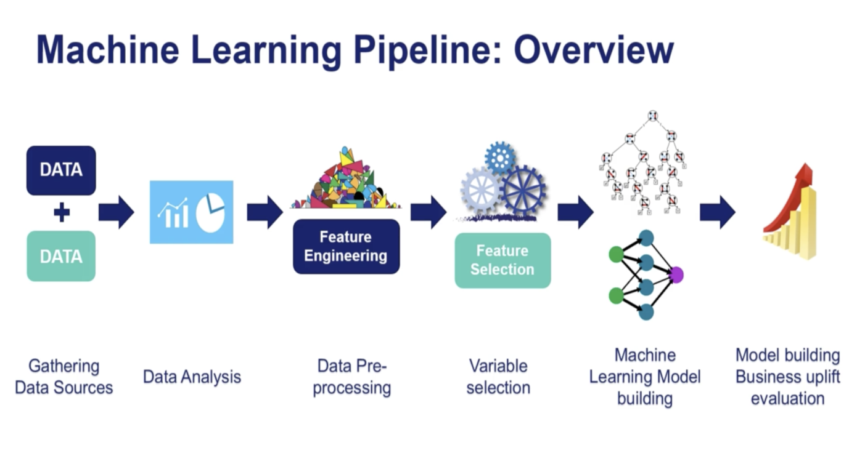

1. **Data pre-processing:**

The most time consuming part of a data science project is the data cleaning and preparation .However there are many powerful tools to expedite this process. One of them being pandas library.

**Handling Null values:**

 In real world data, there are some instances where a particular element is absent because of various reasons, such as, corrupt data, failure to load the information, or incomplete extraction. [Handling](https://analyticsindiamag.com/get-started-preparing-data-machine-learning/) the missing values is one of the greatest challenges faced by analysts, because making the right decision on how to handle it generates robust data models

Pandas treat **None** and **NaN** as essentially interchangeable for indicating **missing** or **null values**.

To facilitate the convention, there are several useful functions for detecting, removing, and replacing null values in Pandas DataFrame:

* isnull()
* notnull()
* dropna()
* fillna()
* replace()
* interpolate()

In order to check missing values in Pandas DataFrame, we use a function isnull() and notnull().

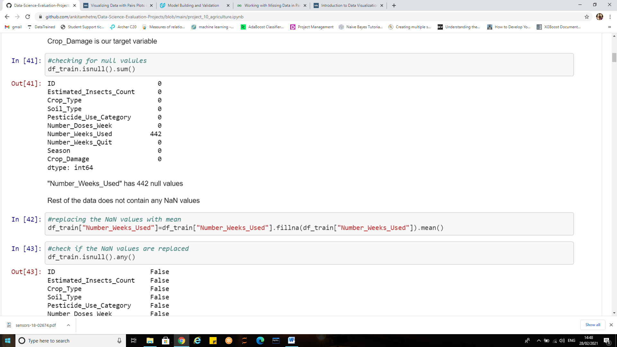

**Methods to treat the Null Values:**

1. **Deleting row:** This method commonly used to handle the null values. Here, we either delete a particular row if it has a null value for a particular feature and a particular column if it has more than 70-75% of missing values.This method is advised only when there are enough samples in the data set. One has to make sure that after we have deleted the data, there is no addition of bias. Removing the data will lead to loss of information which will not give the expected results while predicting the output.
2. **Replacing With Mean/Median/Mode:**

## This strategy can be applied on a feature which has numeric data like the age of a person or the ticket fare. We can calculate the mean, median or mode of the feature and replace it with the missing values. This is an approximation which can add variance to the data set. But the loss of the data can be negated by this method which yields better results compared to removal of rows and columns. This method is also called as leaking the data while training.

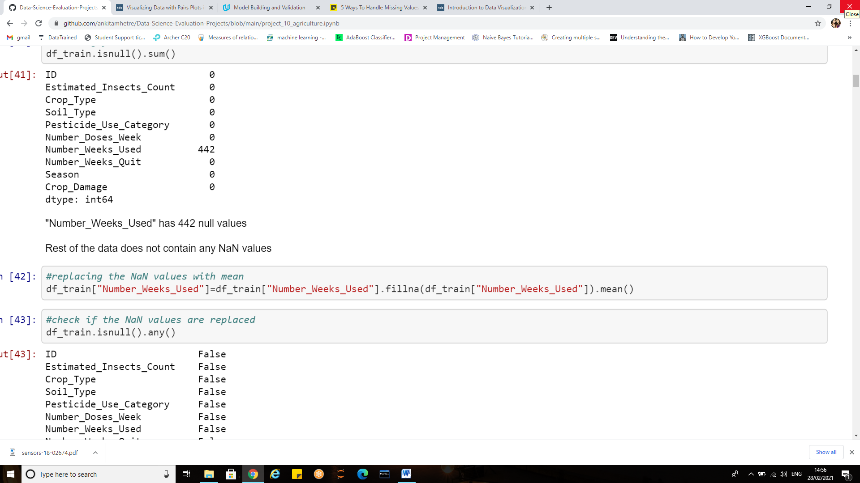

Here we have filled the missing values in “Number_weeks_used”with its mean value.

Crosscheck if the NaN values are filled, we have used isnull().any()method for cross-checking

**2) Feature engineering**:

By now we get a good glimpse of data. It is necessary to remove less correlated variables during feature selection to improve the model.

**Dropping columns that have no relation with target:**

The drop function allows the removal of rows and columns from your DataFrame

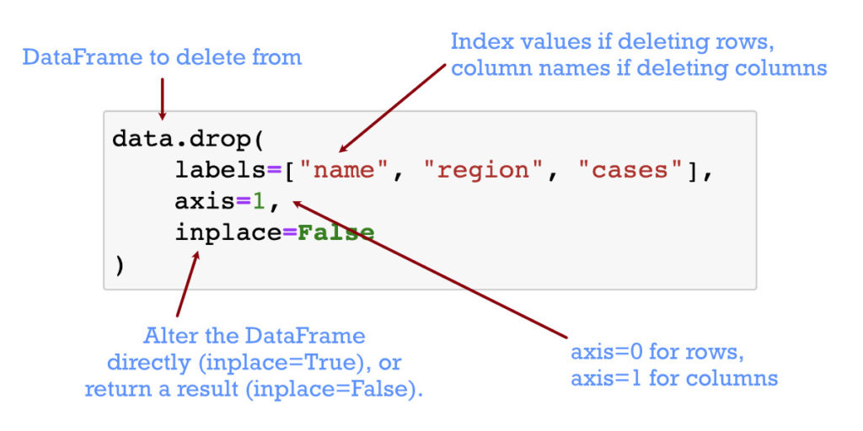

Thus deleting columns and rows is one of the key operations for DataFrame.

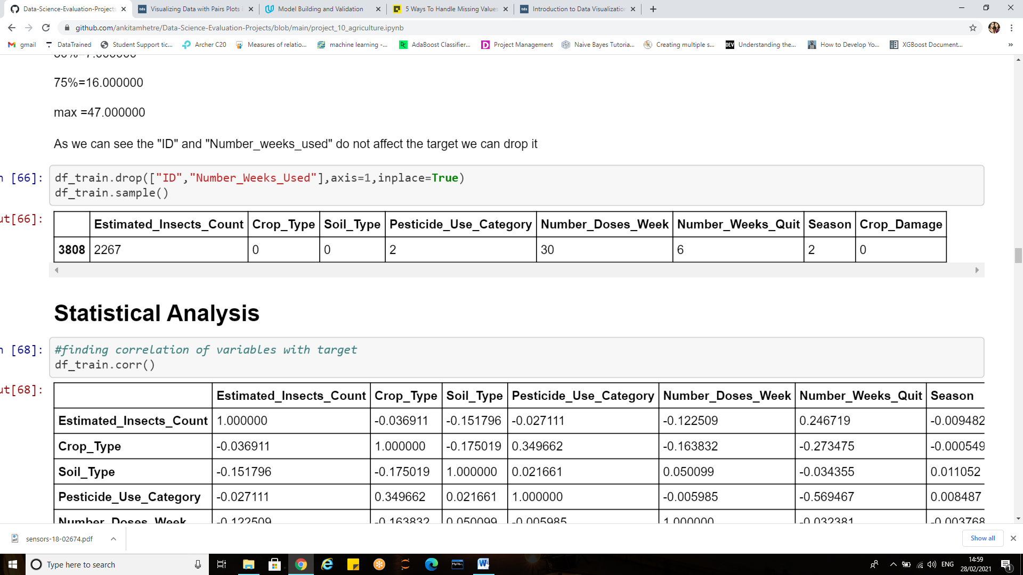

As we can see the "ID" does not affect the target we can drop it also for "Number_weeks_used" about 75% values were Nan which were filled with the mean value but in order to improve the model the ideal approach is to drop it.

1. **Assigning target and features to variables:**

After performing the data cleaning, visualizations and understanding the details of data it is necessary to separate the features(independent variables)from the dependent one(target/label) to train the model

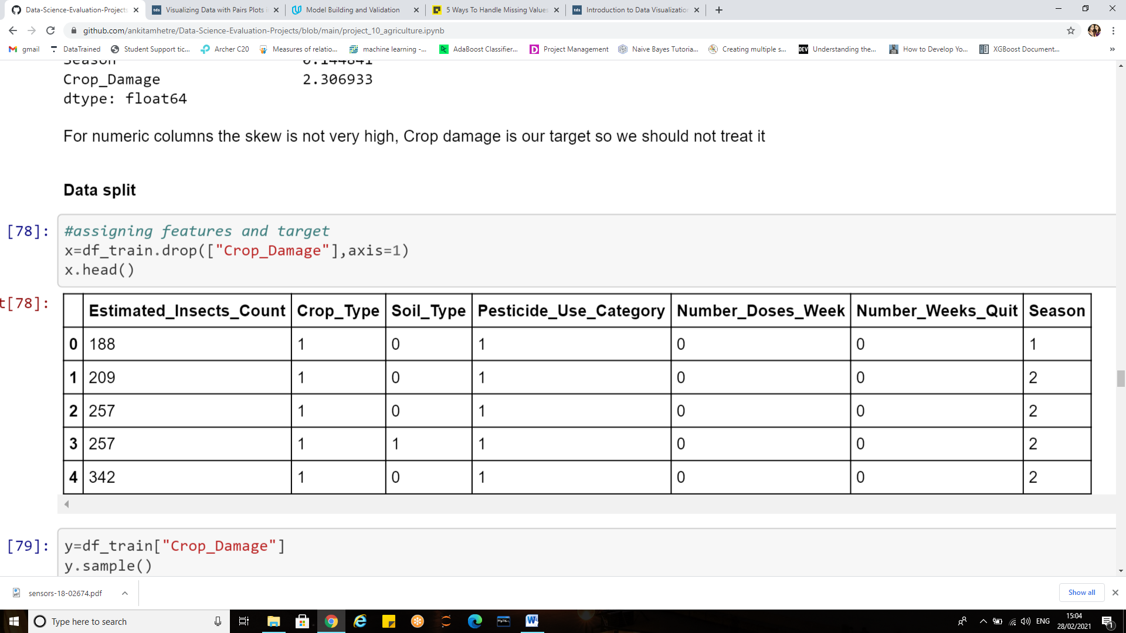

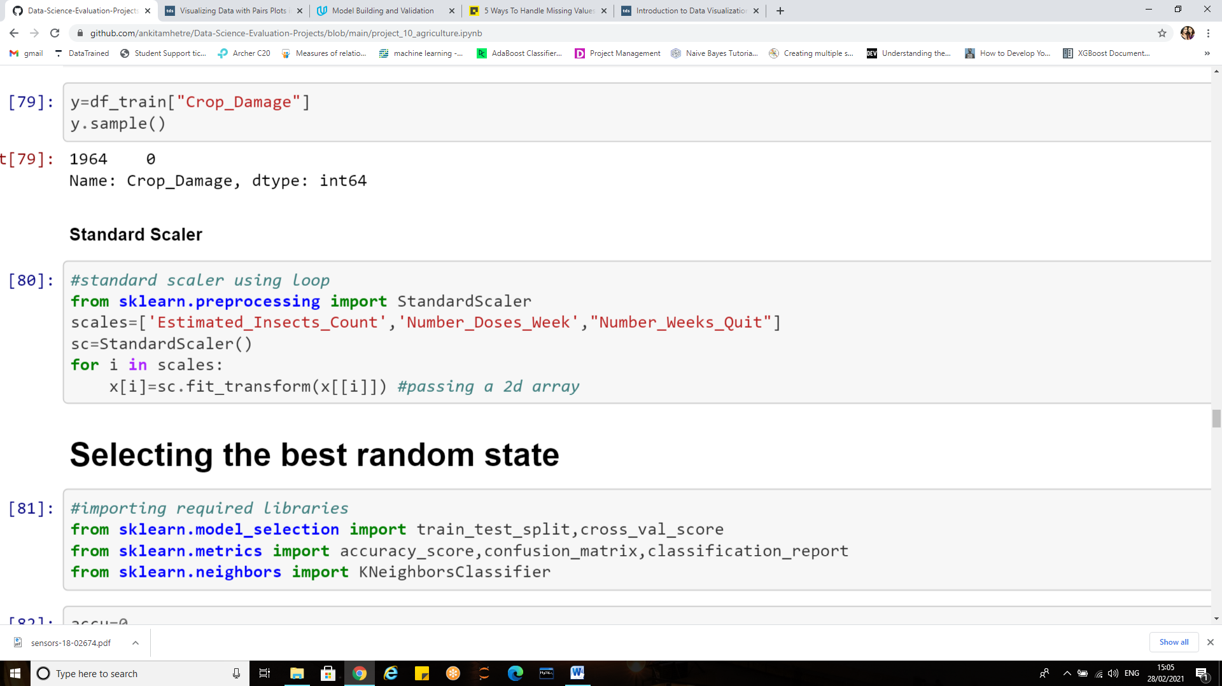

Thus in order to simplify the next steps of data pre-processing, we have separated the source variables (independent variables) from the target variable to be predicted (dependent variable) i.e. ‘Crop damage’.

1. **Skewness:**

Skewness is a measure of the asymmetry of the probability distribution of a real-valued random variable about its mean.

Pandas **dataframe.skew()** function return unbiased skew over requested axis Normalized by N-1.

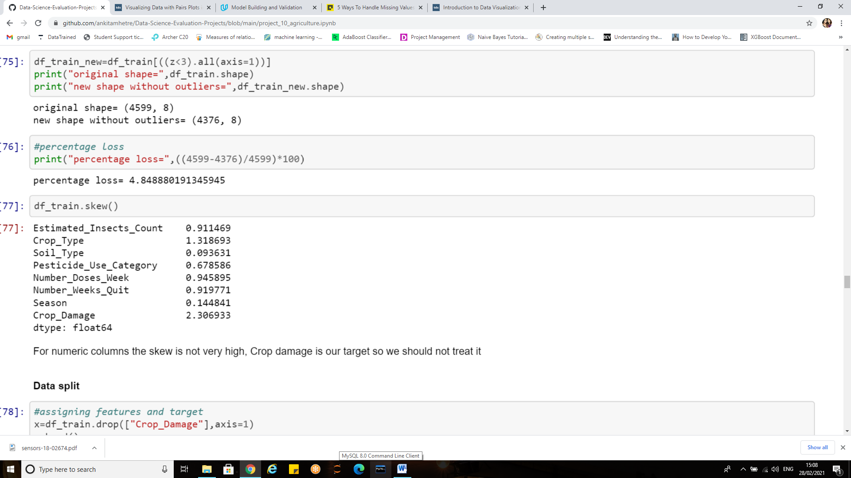

The column with high skew is Crop_Damage which is our target variable and is also categorical so it should not be treated for skewness reduction. For rest of the features skewness is under considerable range so let us not perform any transformations.

The rule of thumb seems to be: If the skewness is between -0.5 and 0.5, the data are fairly symmetrical. If the skewness is between -1 and – 0.5 or between 0.5 and 1, the data are moderately skewed. If the skewness is less than -1 or greater than 1, the data are highly skewed.

But it is always good to know the idea behind skewness and its treatment so let’s have a small read.

The below figure shows a normal distribution/Gaussian distribution which is also known as bell curve.

[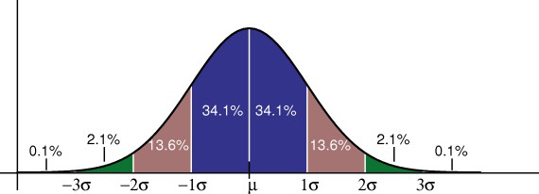](https://www.statisticshowto.com/wp-content/uploads/2013/02/standard-normal-distribution.jpg)

When a distribution is asymmetrical the tail of the distribution is skewed to one side either to the right or to the left. The left and right skew is best represented in figure below

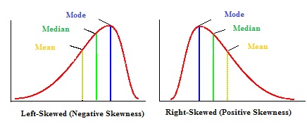

*Why should we treat the skewness of data?*

Many machine learning algorithms prefer or perform better when numerical variables have a Gaussian probability distribution .If the values of a certain independent variable (feature) are skewed, depending on the model, skewness may violate model assumptions (e.g. logistic regression) or may impair the interpretation of feature importance.

Therefore it is often desirable to treat the skewness  So, the more the data is close to normal, the better it is for getting good predictions.

We can address skewed variables by transforming them (i.e. applying the same function to each value). Common transformations include **square root (sqrt(x)), logarithmic (log(x)), Box Cox Transformation and reciprocal (1/x).**

Scikit-learn library provides Power transforms like the **Box-Cox** transform and the **Yeo-Johnson** transform which provides an automatic way of performing these transforms on data to reduce the skew.

**Note:**

* The target variable should not be treated for skewness.
* Box-cox method can be used to treat only positive skew

1. **Standardization**

It is another integral pre-processing step. In Standardization, we transform our values such that the mean of the values is 0 and the standard deviation is 1.

If the features in dataset are not on the same scale our model will give different weightage to each feature, which is not the ideal scenario. In order to avoid this issue, we perform Standardization.

**MinMaxScaler(feature range = (0, 1))** will transform each value in the column proportionally within the range [0,1]. Use this as the first scaler choice to transform a feature, as it will preserve the shape of the dataset (no distortion).

**StandardScaler()** will transform each value in the column to range about the mean 0 and standard deviation 1, i.e., each value will be normalised by subtracting the mean and dividing by standard deviation. Use StandardScaler if you know the data distribution is normal.

We don’t need to do this process manually as sklearn provides a function called **StandardScaler and MinMaxScaler.**

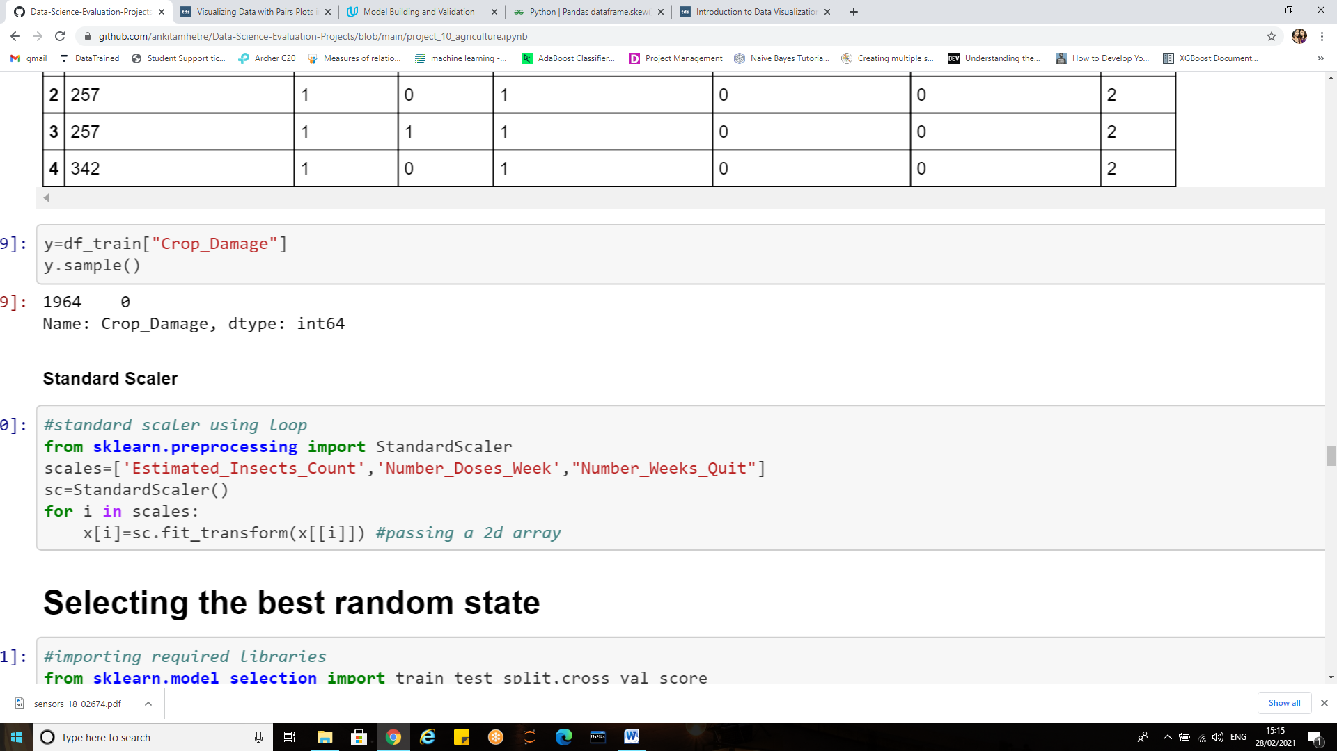

**fit_transform** is equivalent to using fit and then transform.

**Note:** use only the transform method when dealing with the test data*.*

1. **Splitting the Dataset into the Training set and Test set**

The procedure involves taking a dataset and dividing it into two subsets. The first subset is used to fit the model and is referred to as the training dataset.

The second subset is not used to train the model; instead, the input element of the dataset is provided to the model, then predictions are made and compared to the expected values. This second dataset is referred to as the test dataset.

* Train Dataset: Used to fit the machine learning model.
* Test Dataset: Used to evaluate the fit machine learning model.

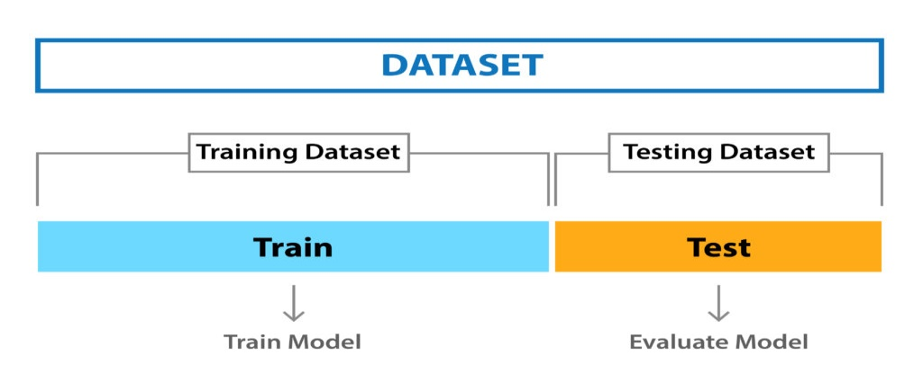

**Note:** Before we split the data into train and test sets we should find the best random state using loop

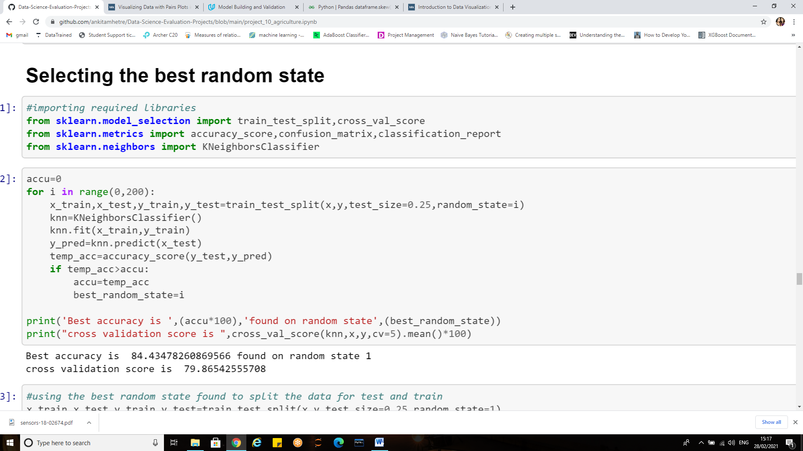

We have checked for the best random state in the range from 0 to 200 using KNN classifier and the best random state we get is 1 which is providing us with an accuracy of 84.43

1. **Data split**

Based upon the best random state found we proceed with the splitting of dataset into train and test set

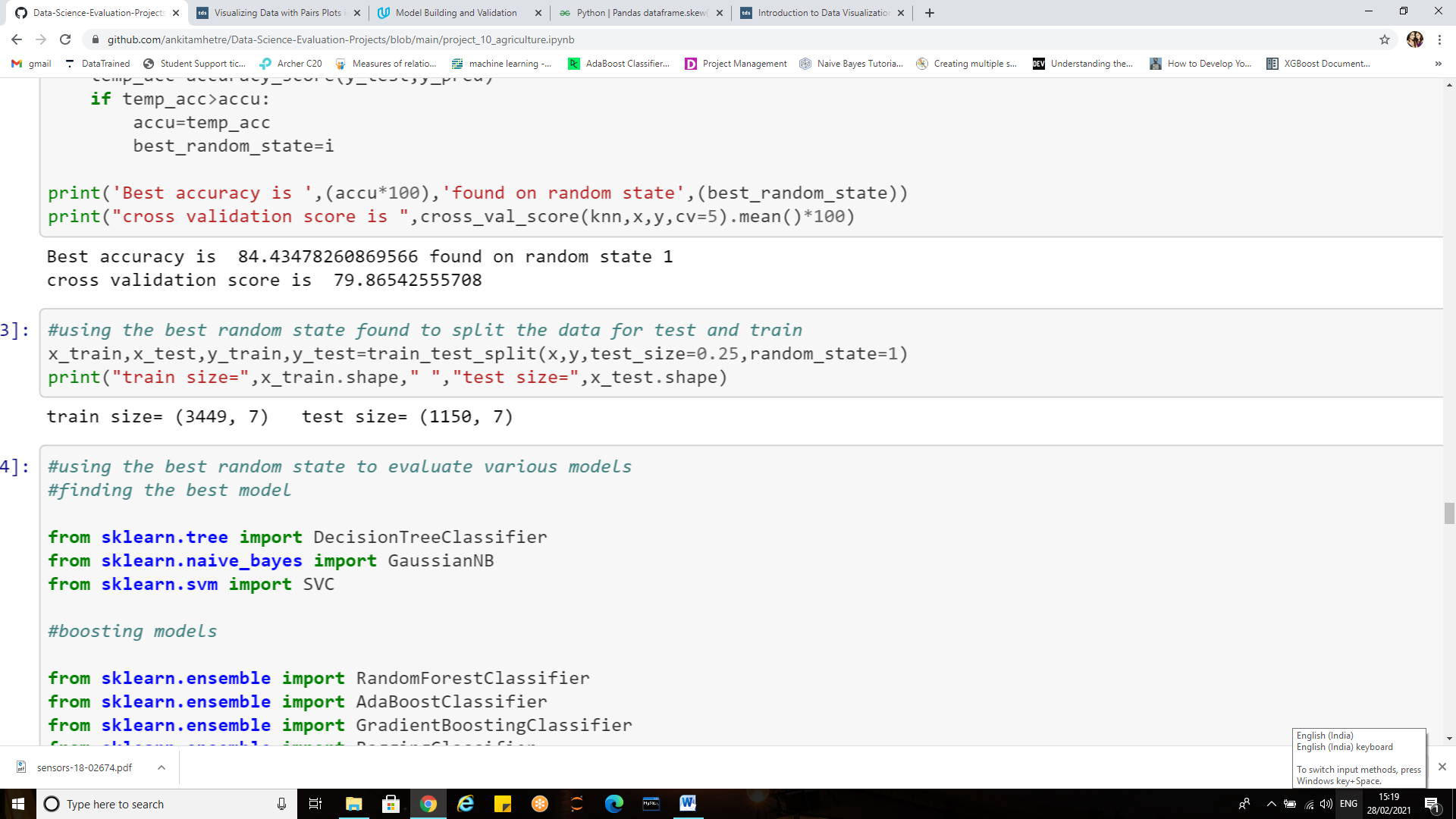

Train size=75% of the dataset which is 3449 rows and 7 columns

Test Size=25% of the dataset i.e. 1150 rows and 7 columns

**Building Machine Learning Model:**

Now that we are reaching towards the end of data science life cycle our last step is to build the model that will reflect all our work done so far.

A machine learning model is a file that has been trained to recognize certain types of patterns. You train a model over a set of data, providing it an algorithm that it can use to reason over and learn from those data.



**Importing all required libraries:**

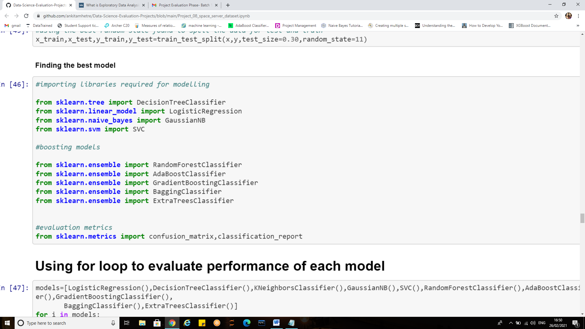

Before building our model using any one algorithm let us study the performance of various algorithms and then decide for the best one, For which here we use a loop and understand the general outcomes.

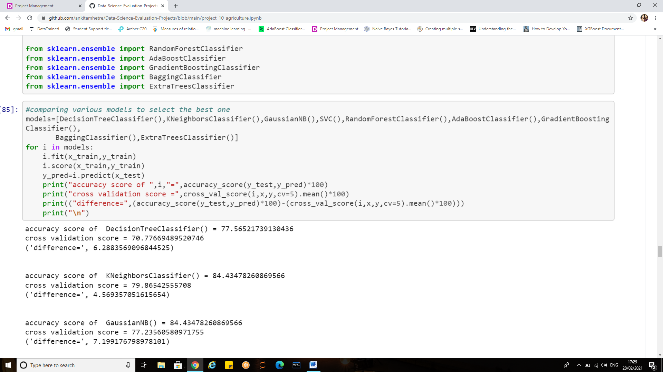

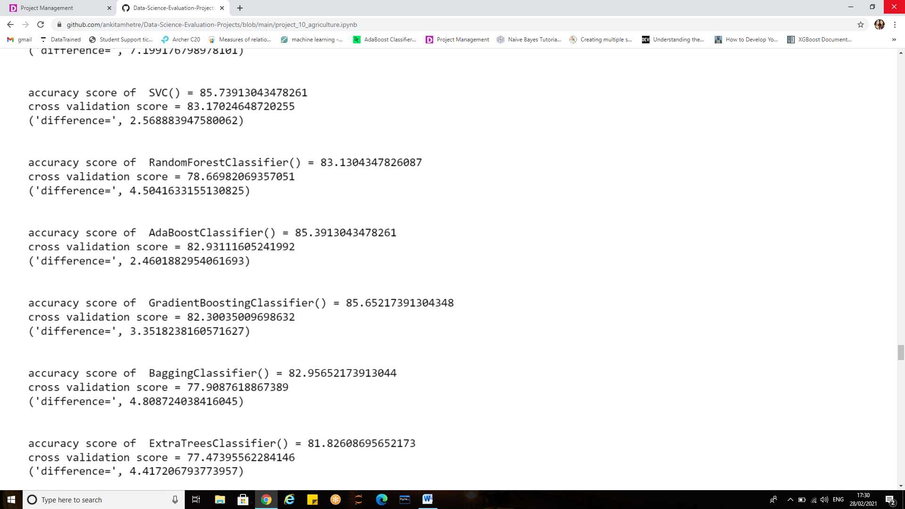

To select the best of all consider the one which yields us the minimum difference between its accuracy and the cross validation score.

#### Thus the differences between cross validation and accuracy score is less for Gradient Boosting. We shall hyper tune it and see for the scores.

**Hyper tuning the models:**

When creating a machine learning model, we'll be presented with design choices as to how to define our model architecture. Often times, we don't immediately know what the optimal model architecture should be for a given model, and thus we'd like to be able to explore a range of possibilities. In machine learning we'll ideally ask the machine to perform this exploration and select the optimal model architecture automatically.

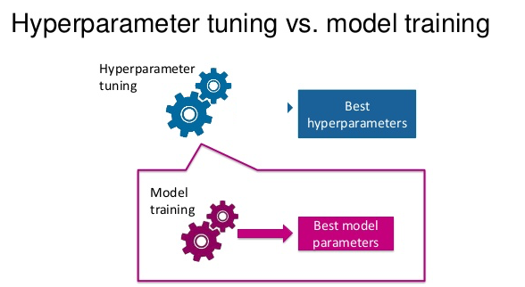

Parameters which define the model architecture are referred to as **hyper parameters** and thus this process of searching for the ideal model architecture is referred to as **hyper parameter tuning.**

Models can have many hyper-parameters and finding the best combination of parameters can be treated as a search problem.

Two best strategies for Hyper-parameter tuning are:

* [GridSearchCV](https://scikit-learn.org/stable/modules/generated/sklearn.model_selection.GridSearchCV.html)
* [RandomizedSearchCV](https://scikit-learn.org/stable/modules/generated/sklearn.model_selection.RandomizedSearchCV.html)

**Hyper parameter tuning for Gradient Boosting classifier:**

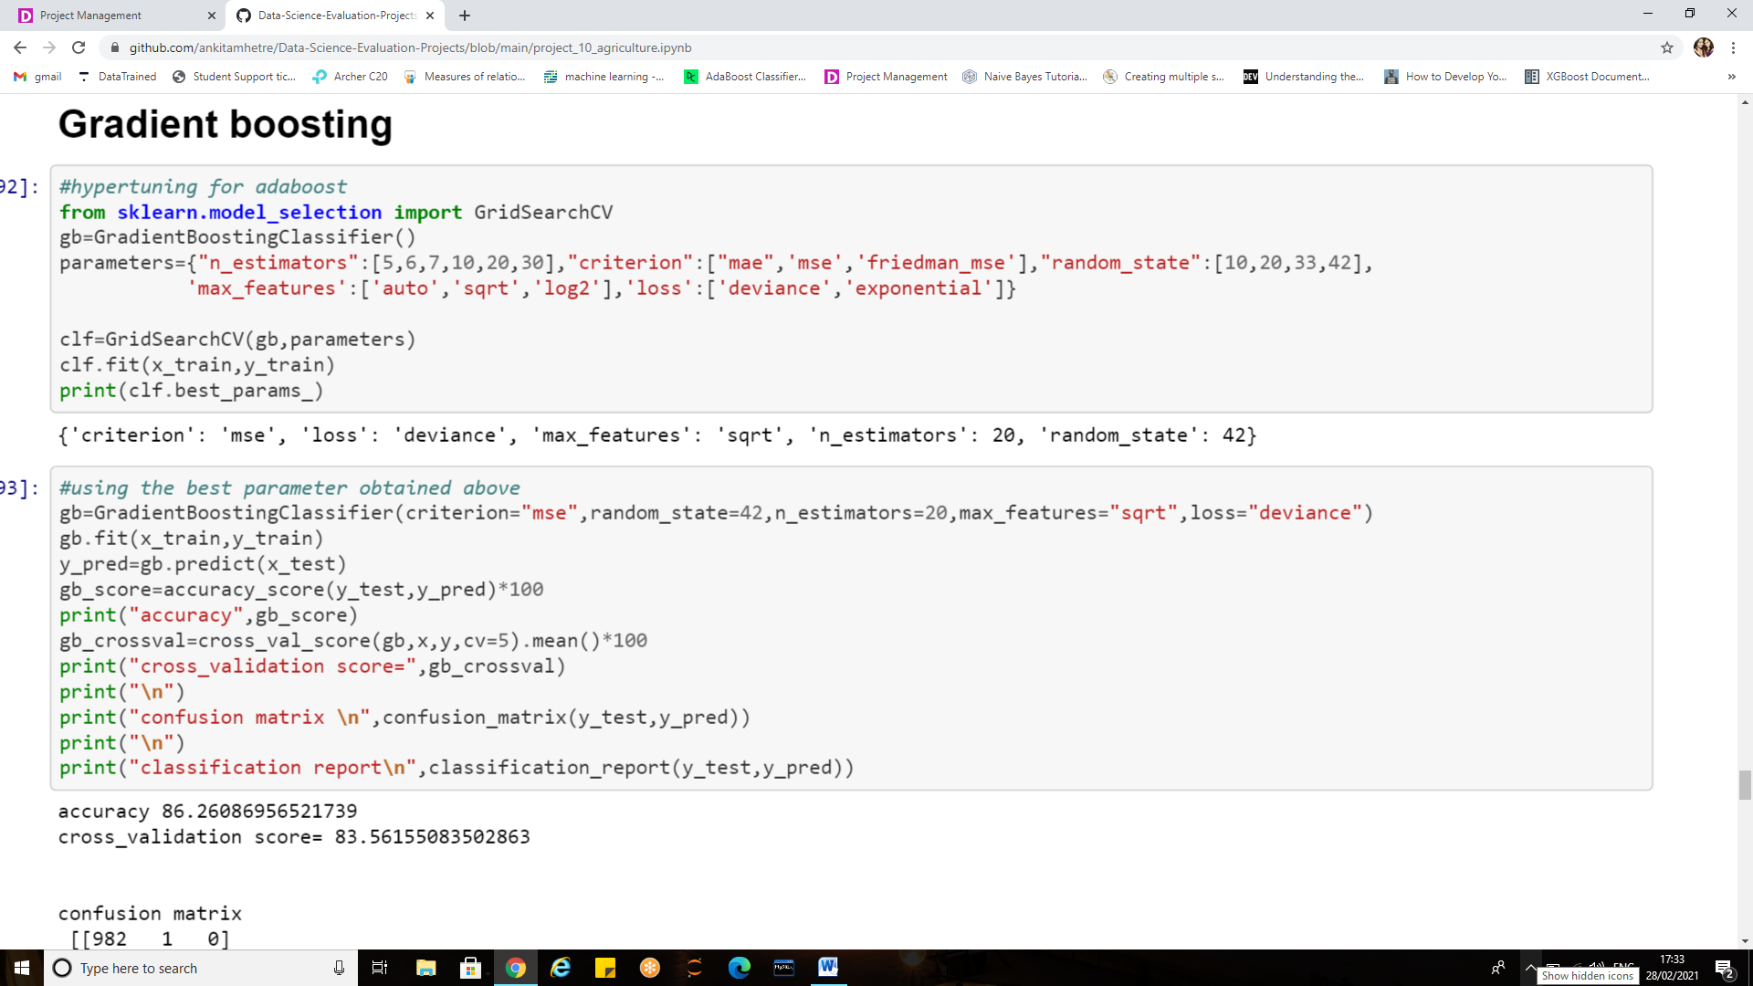

The hyper parameters which I decided to focus on are:

* **max_features**:The number of features to consider while searching for a best split. These will be randomly selected.
* **n_estimators**:The number of sequential trees to be modelled .Though GBM is fairly robust at higher number of trees but it can still overfit at a point. Hence, this should be tuned using CV for a particular learning rate.
* **Loss**: It refers to the loss function to be minimized in each split.
* **random_state**: The random number seed so that same random numbers are generated every time. This is important for parameter tuning. If we don’t fix the random number, then we’ll have different outcomes for subsequent runs on the same parameters and it becomes difficult to compare models.
* **Criterion:** The function to measure the quality of a split.

**Using the best parameters obtained to build the model**

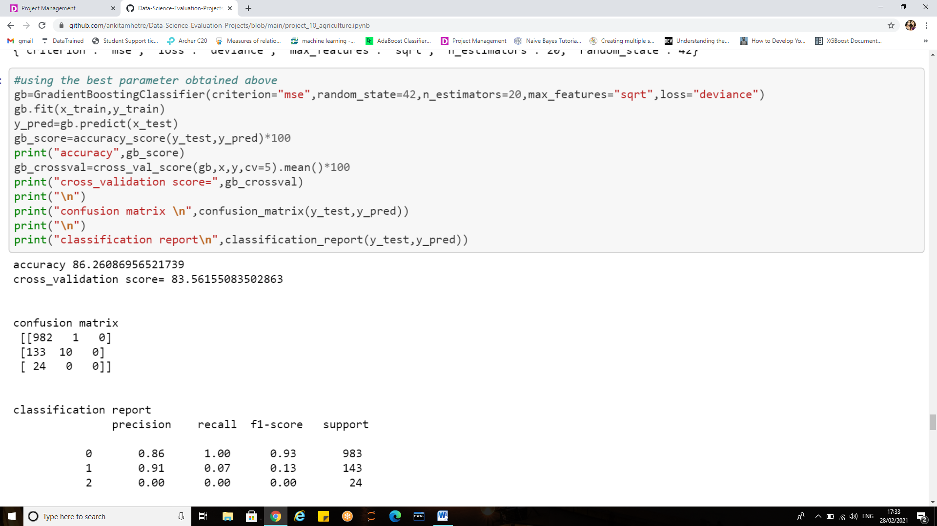

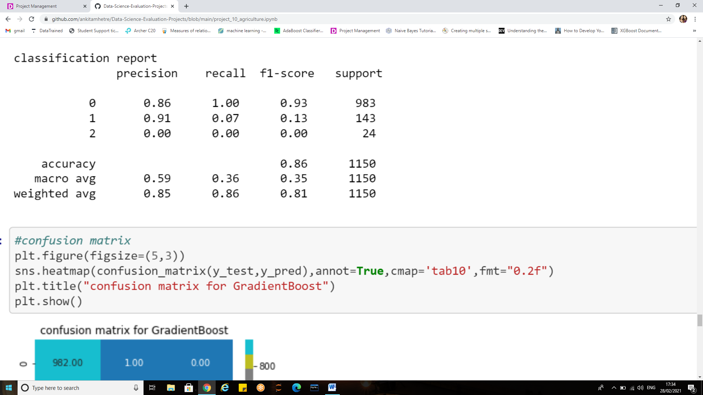

**Cross Validation Score:**

Cross-validation is primarily used in applied machine learning to estimate the skill of a machine learning model on unseen data, in order to flag problems like over-fitting or selection bias and to give an insight on how the model will generalize to an independent dataset (i.e., an unknown dataset, for instance from a real problem).

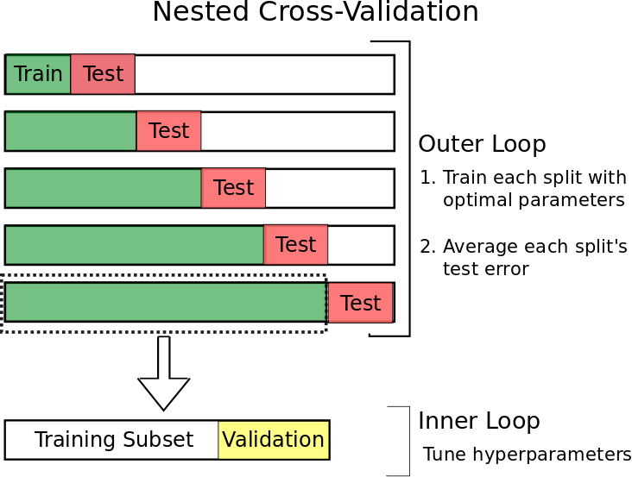

This approach involves randomly dividing the set of observations into k groups, or folds, of approximately equal size. The first fold is treated as a validation set, and the method is fit on the remaining k − 1 folds*.*

So **cross_val_score** estimates the expected accuracy of model on out-of-training data (pulled from the same underlying process as the training data, of course).

**Evaluation Metrics**

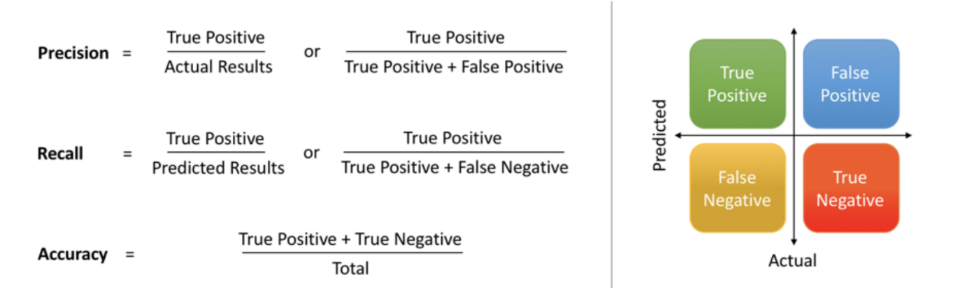

**Accuracy Score**

Classification accuracy (Accuracy score) is the number of correct predictions made as a ratio of all predictions made.

### Classification Report

Scikit-learn do provide a convenience report when working on classification problems to give a quick idea of the accuracy of a model using a number of measures.

The classification_report () function displays the precision, recall, f1-score and support for each class.

The scikit-learn documentation explains these concepts best

**Confusion matrix**

The confusion matrix is a handy presentation of the accuracy of a model with two or more classes.

The table presents predictions on the x-axis and accuracy outcomes on the y-axis. The cells of the table are the number of predictions made by a machine learning algorithm.

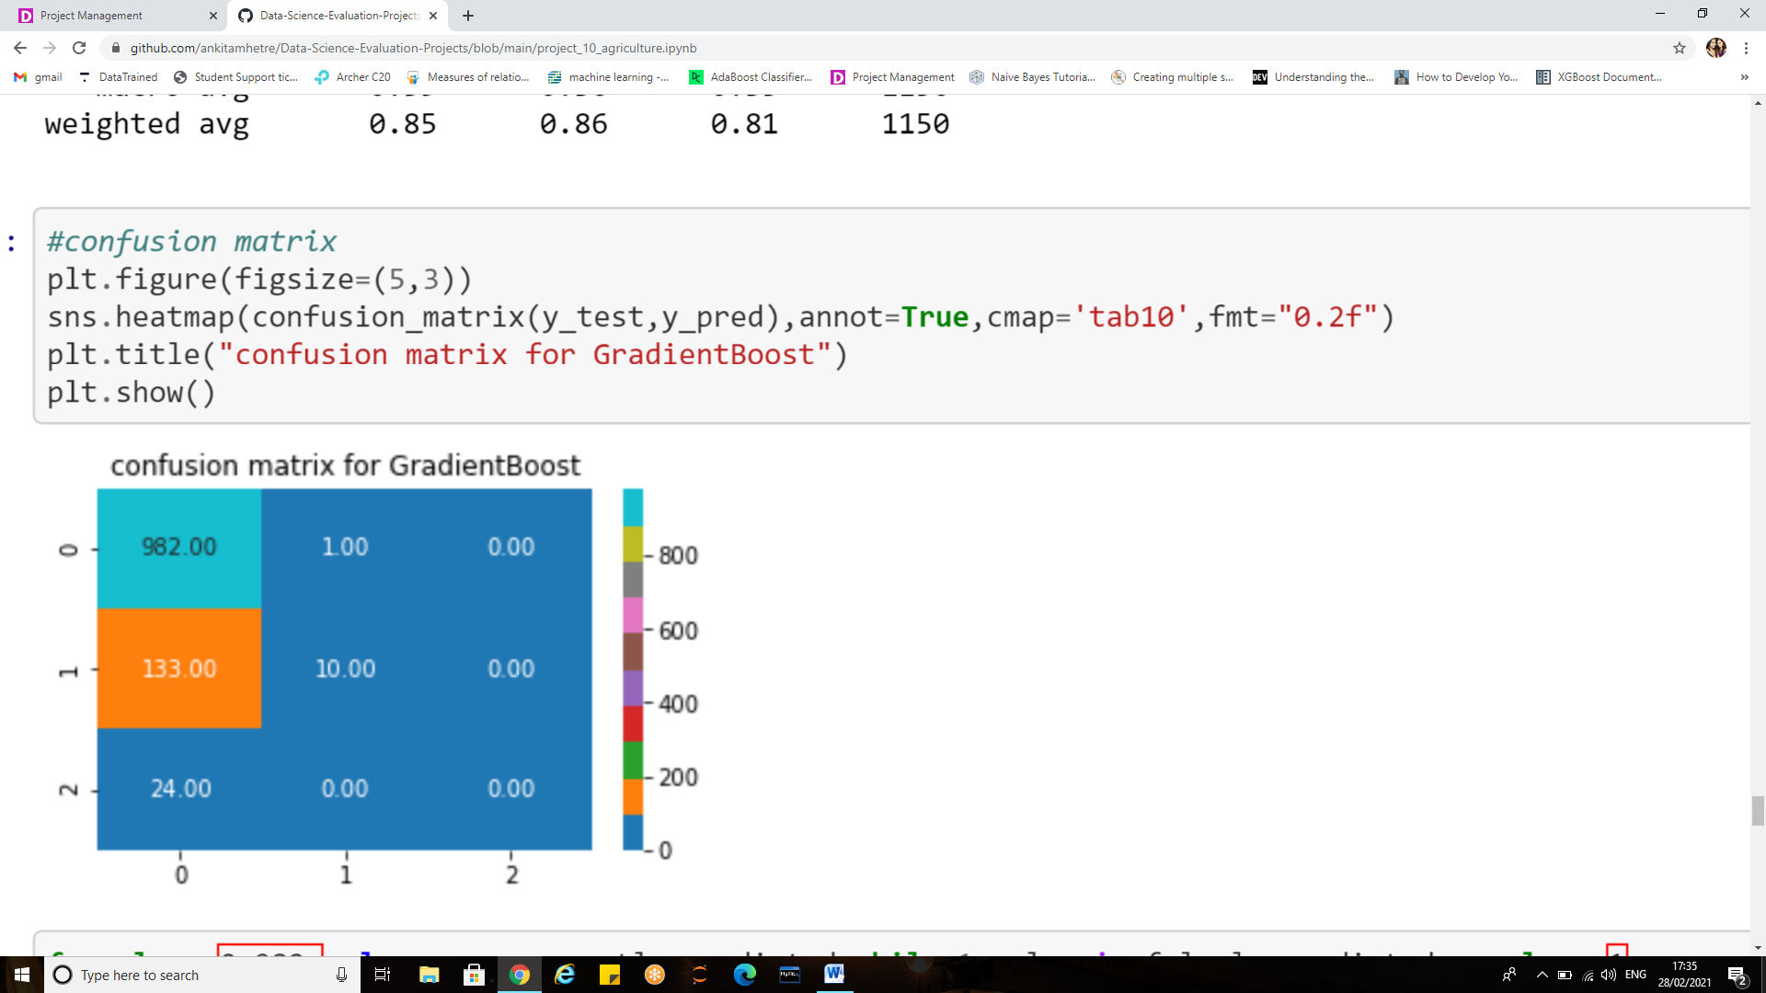

**Reading the confusion matrix**

* **for class 0**: 982 values are correctly predicted while 1 value is falsely predicted as class 1
* **for class 1**:10 values are correctly predicted while there are 133 error which are predicted as class 0
* **for class 2** : 0 values are correctly predicted while 24 are wrongly predicted as class 0

**Saving the best model:**

After trying and testing various classification algorithms the final step is to save the best trained model so that we can restore them and use the fitted/trained model in future to make predictions on new data.

What would be a best model?

* A model with maximum accuracy/least errors
* A model that uses the maximum information available in the given dataset
* A model that can capture all hidden patterns in the data
* Amodel that can produce the best prediction results



The saving of data is called **Serialization**, while restoring the data is called **Deserialization.**

* **pickle.dump** to serialize an object hierarchy, you simply use dump ().
* **pickle.load** to deserialize a data stream, you call the load() function*.*

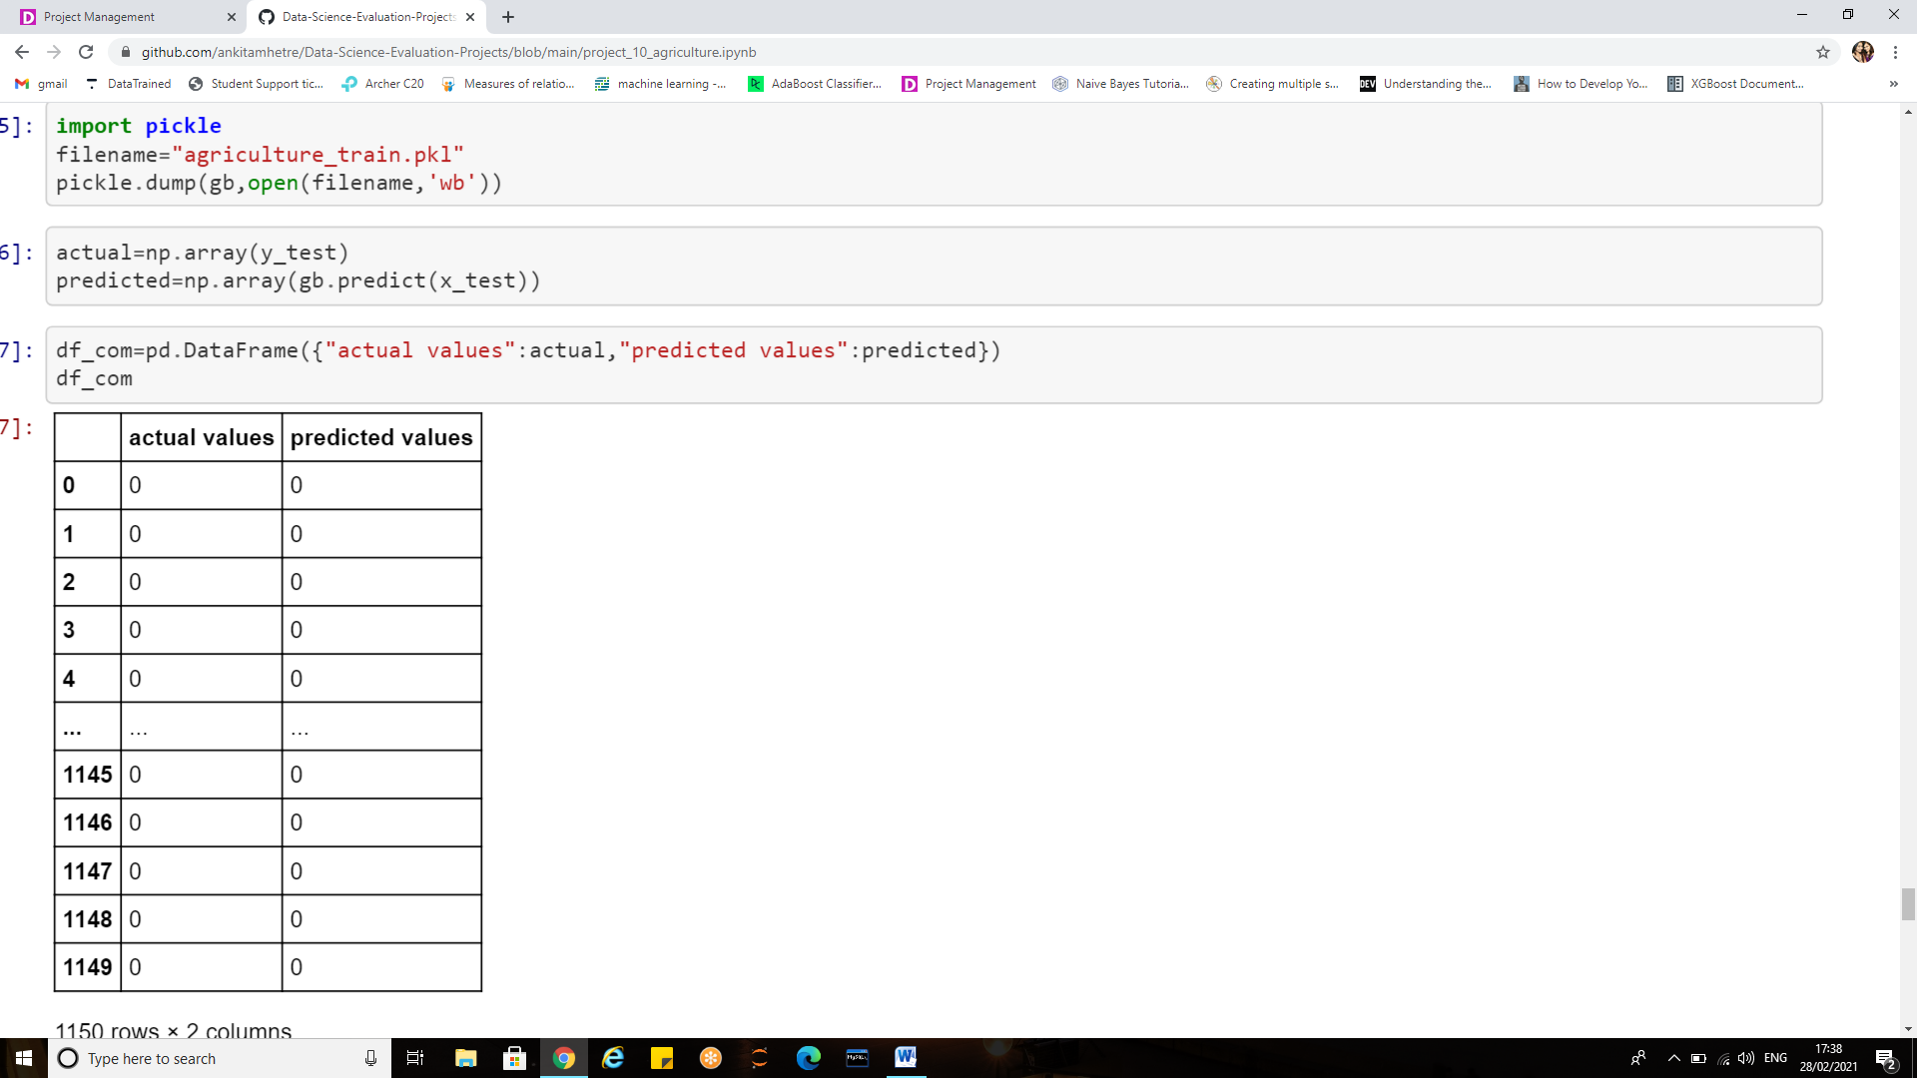

Thus the model is saved using pickle.dump. While working on the test data we will be recalling this saved model using pickle.load method to predict the values for test dataset or any new dataset in the future.

The model can also be saved using **joblib**

Joblib is the replacement of pickle as it is more efficient on objects that carry large numpy arrays.

* joblib.dump to serialize an object hierarchy
* joblib.load to deserialize a data stream

The predicted values can also be stored **as csv file** using the following syntax:

pd.to_csv (“filename.csv”)

The csv file will be reflected on the home page.

**Working on the test dataset:**

In this case there are 2 different datasets train dataset and the test dataset, We have already trained the model using train dataset .Now we need to perform all the pre-processing steps for test data and predict the target values for test dataset. We can use the trained model anytime anywhere to make predictions for the data we might receive in future.

***As machine learning stage is all about looking into the future!***

All the below snippets refers to the pre-processing step that were performed on train dataset

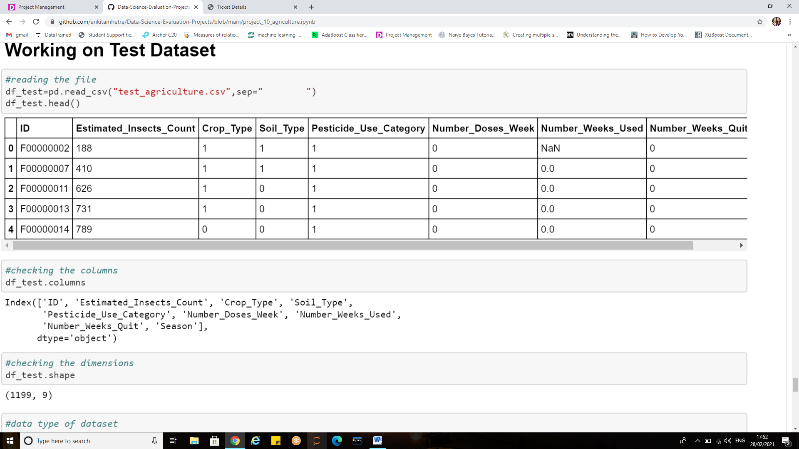

It can be observed that the target column i.e. crop damage is missing this dataset.

*Looking at the columns do we get an idea of what we are trying to do?*

Exactly!! Get back my saved model and predict those crop damage values for this dataset!!!!

Before we make predictions let us quickly review the data and its characteristics once.

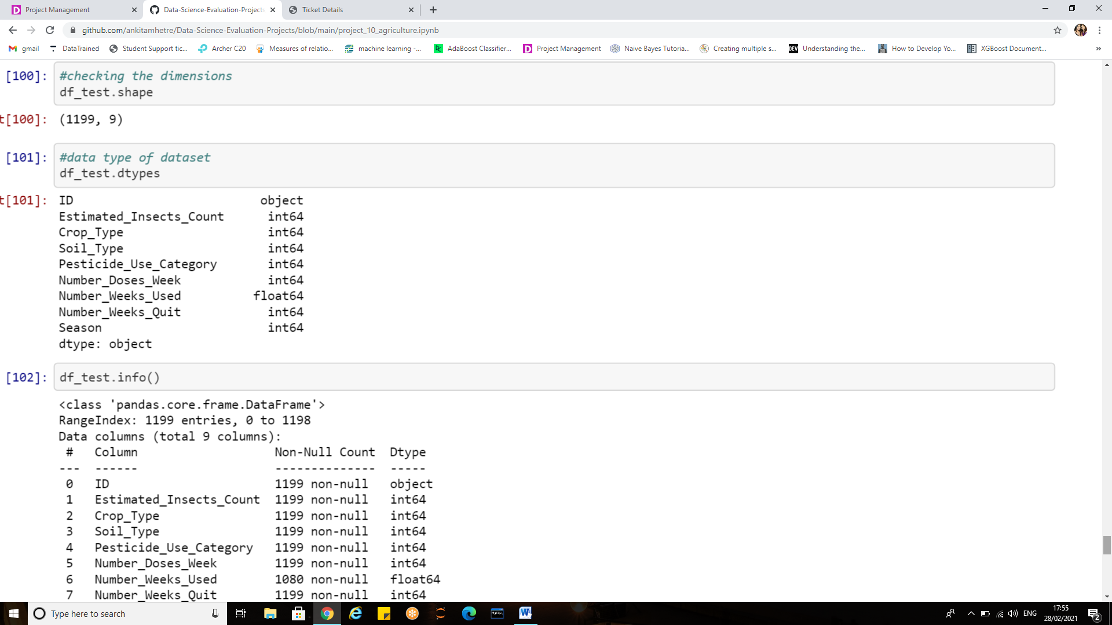

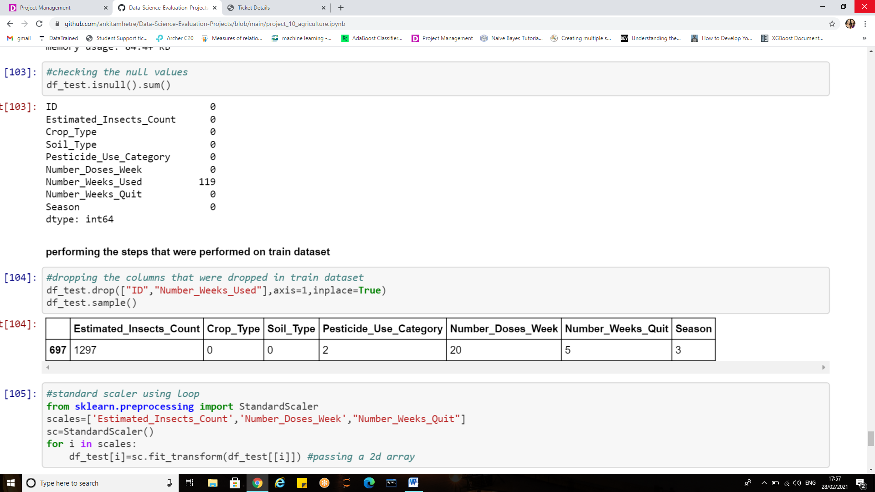

Have a thorough look at the below steps where we will be performing the pre-processing step that were performed on the train dataset.

1. **Drop the un-necessary columns**

What if we don’t drop this in test dataset?

It is always necessary to make sure that the dataset for which we are trying to predict will have the same number of features that the trained model had. In our case these 2 features were dropped from the dataset on which the model was trained therefore, it becomes a mandatory step here as well. Else the model will throw errors for inconsistent feature or data size.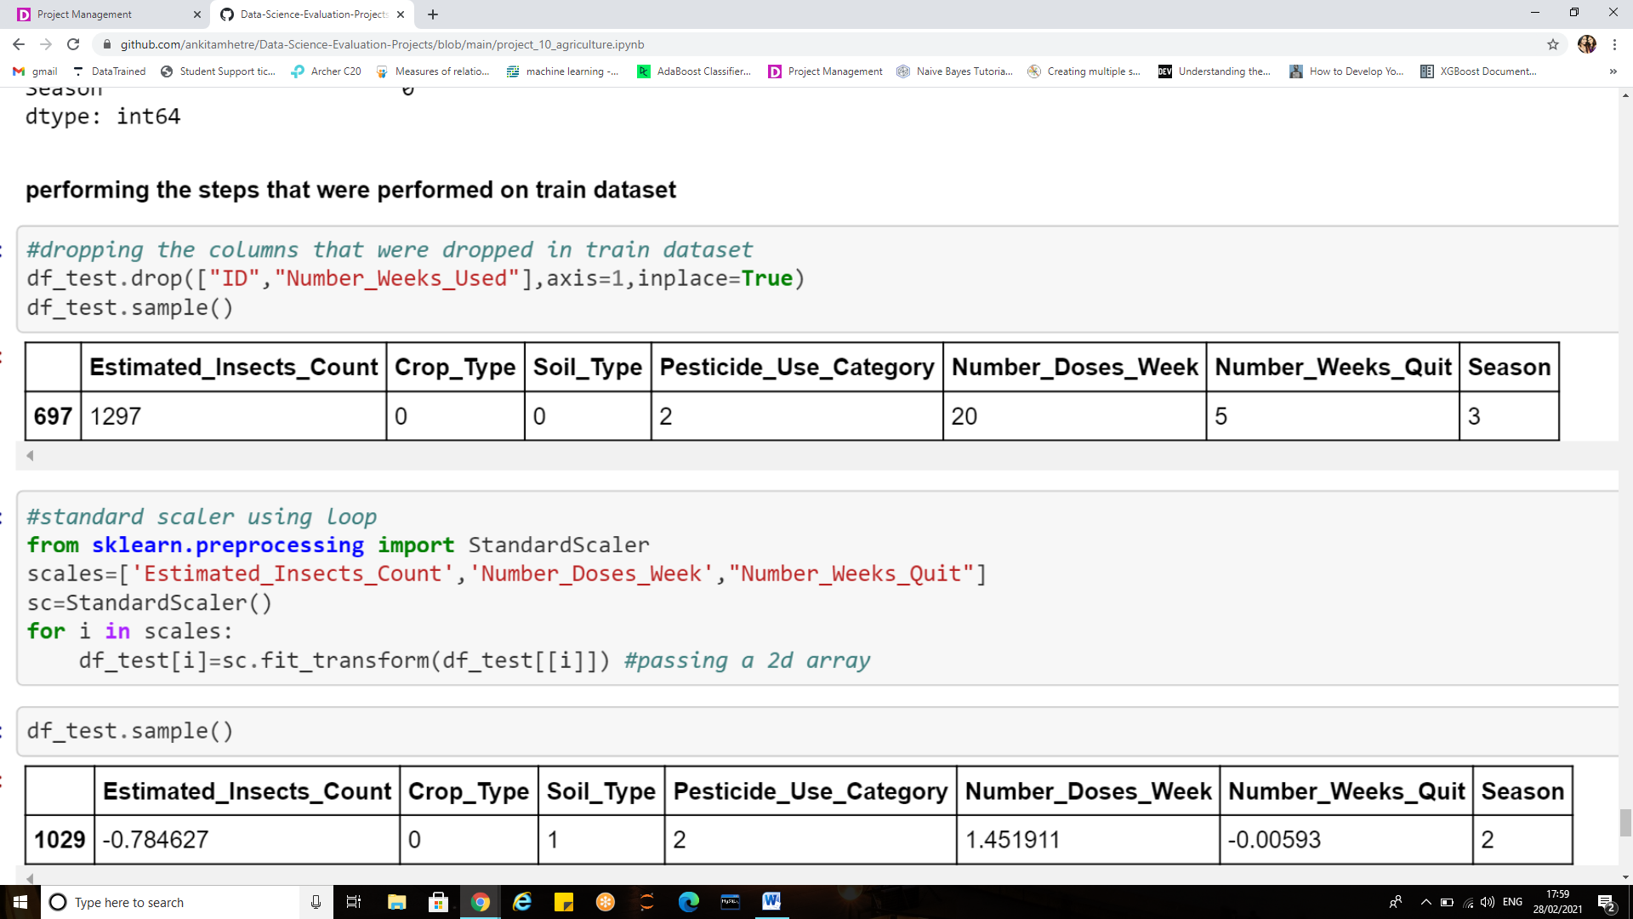

1. **Standar scailing**

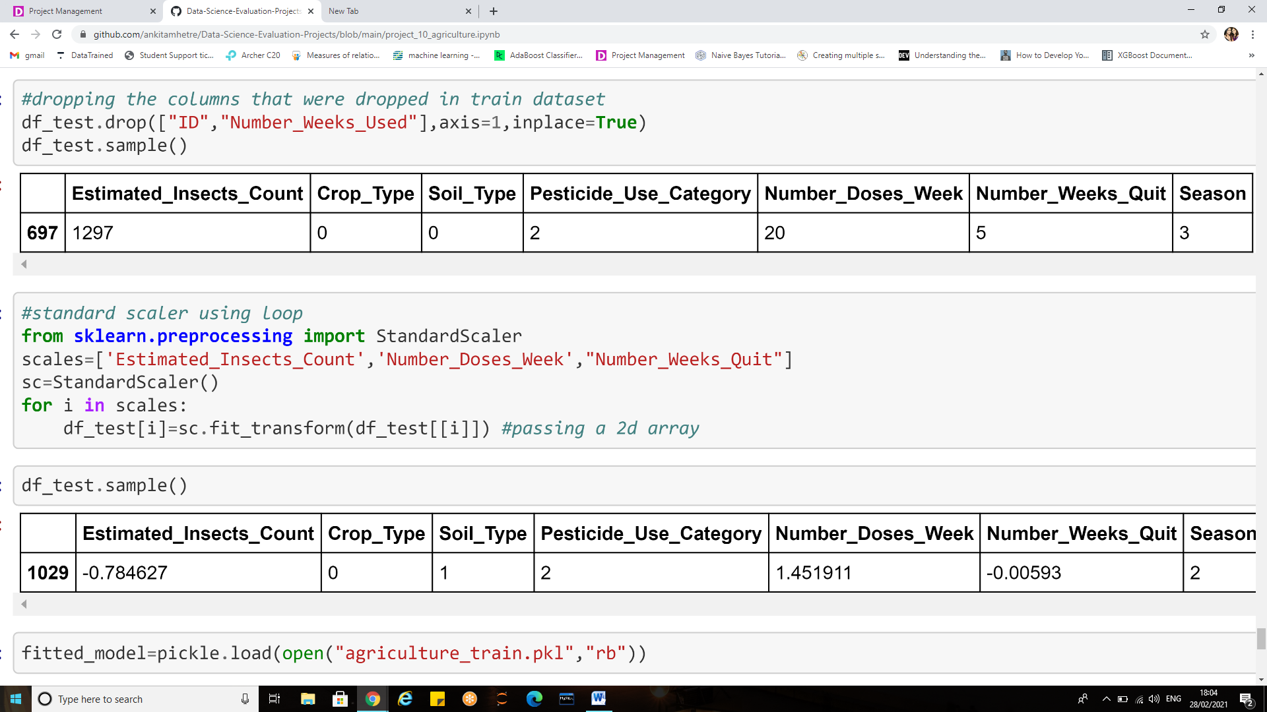

Now that our data is ready we shall restore the saved model and predict the values with no further delay.

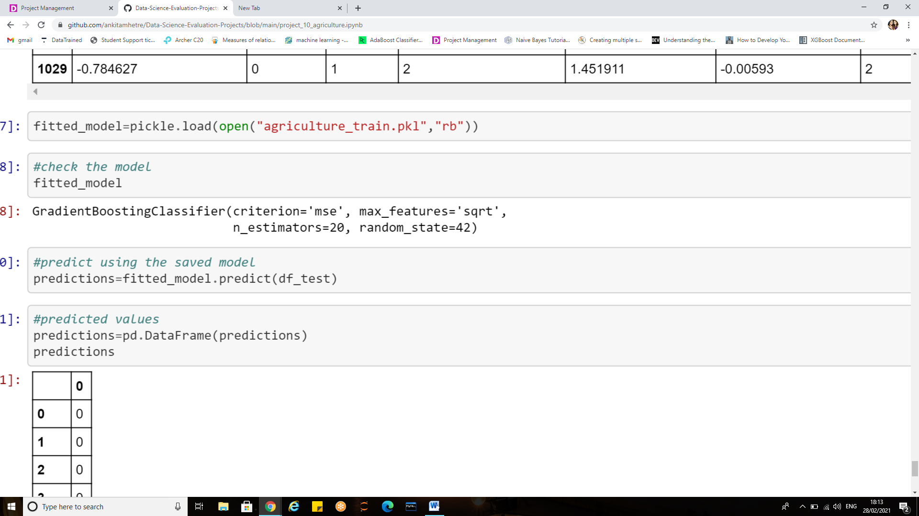

Can we recall our saved model? Well that should not be a problem if only the filename is known to you ,we can easily retrieve the model with the above lines of code.

The ‘fitted model’ is a variable that stores the model, various parameters that were used to hyper tune and train the model can be seen.

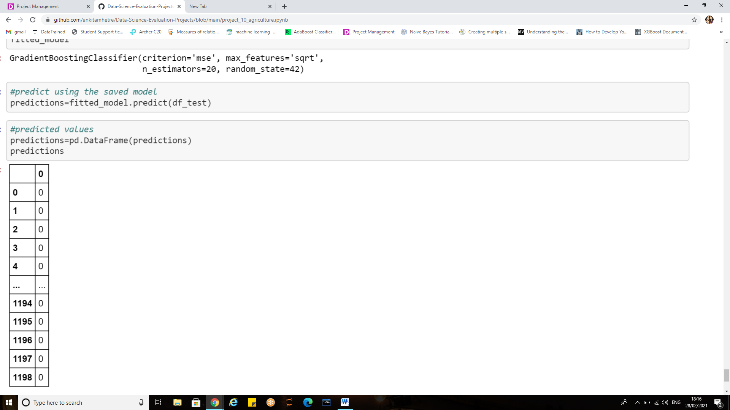

Finally we have our predictions in place.

**Conclusion**

* The industry is turning to Artificial Intelligence technologies to help yield healthier crops, control pests, monitor soil, and growing conditions, organize data for farmers, help with the workload, and improve a wide range of agriculture-related tasks in the entire food supply chain.
* We have performed various data cleaning and pre-processing techniques before proceeding with the model building.
* After evaluation of various algorithms it was found that “Gradient Boosting classifier” gave the best possible accuracy which lead to correct predictions.
* The model has accuracy score of 86.6 and cross validation score of 83.56.
* The trained model is saved, this saved model is then used to make predictions on the test data set
* Various evaluation metrics such as accuracy score, cross validation, classification report and confusion matrix are also observed.
* There are various machine learning applications that can help farmers to increase yield, meet the ever-growing demand for agricultural products, and save the environment.
* Despite agriculture being a very data-centric industry, there are significant challenges on the way to the global adoption of machine learning.

**References:**

<https://www.learndatasci.com/tutorials/python-pandas-tutorial-complete-introduction-for-beginners/>

<https://dev.to/overrideveloper/understanding-the-confusion-matrix-264i>

<https://matplotlib.org/stable/tutorials/index.html>

<https://scikitlearn.org/stable/modules/generated/sklearn.ensemble.GradientBoostingClassifier.html>

<https://machinelearningmastery.com/k-fold-cross-validation/>

<https://www.ritchieng.com/machine-learning-evaluate-classification-model/>

<https://en.wikipedia.org/wiki/Multi-label_classification>

**Thank you.**